
Have Yourself a Merry Little Christmas
C103 C
(Hugh Martin and Ralph Blane, 1943, 1957)
Have Yourself a Merry Little Christmas by Frank Sinatra (1957)

Intro C - F - Dm - G7  C Am Dm G7 C Am Dm G7  Have yourself a merry little Christmas, let your heart be light  C Am Dm G7 E7 A7 D G7  From now on, our troubles will be out of sight  C Am Dm G7 C Am Dm G7  Have yourself a merry little Christmas, make the yule-tide gay  C Am Dm E7 C7  From now on, our troubles will be miles a-way  Chorus  C Bm Am D7 G  Here were are as in olden days, happy golden days of yore  Em Bm D A Am D7  Faithful friends who are dear to us, gather near to us once more  G Em Am D7 G Em Am D7  Through the years we all will be to-gether, if the fates allow  G Em Am D Em G7  Hang a shining star upon the highest bough  C Am D7 G C Am G  And have yourself a merry little Christmas now.  Repeat From Chorus  Outro  C Am D7 G C Am G  And have yourself a merry little Christmas now. |  |  |  |  |  |  | 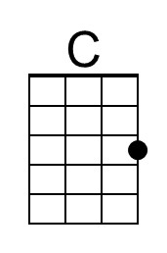 | 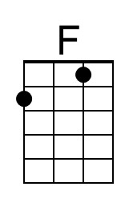
 |  |  |  |  |  |  | 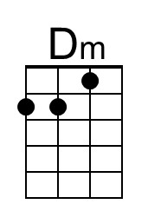 | 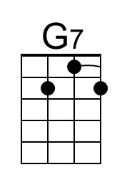
 |  |  |  |  |  |  | 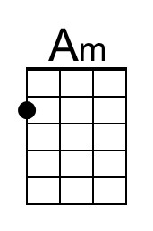 | 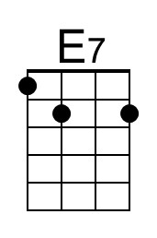
 |  |  |  |  |  |  | 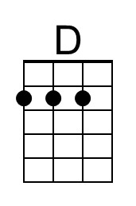 | 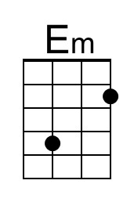
 |  |  |  |  |  |  | 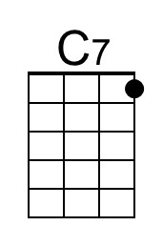 | 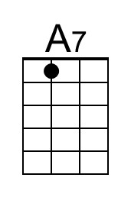
 |  |  |  |  |  |  | 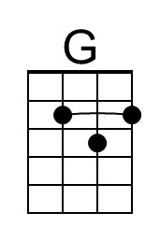
Baritone | 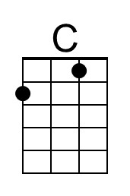 | 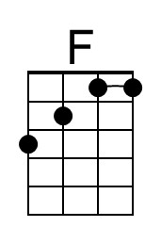 | 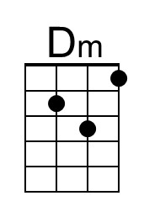 | 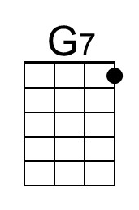 | 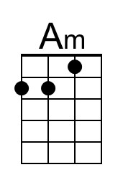 | 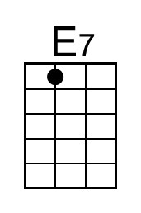
 | 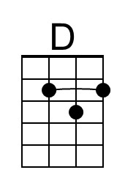 | 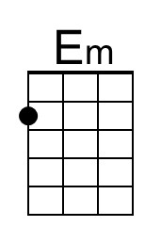 | 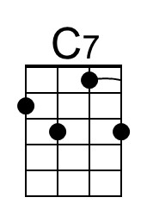 | 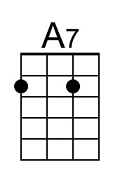 | 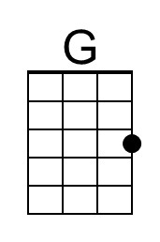
Have Yourself a Merry Little Christmas
C103 G
(Hugh Martin and Ralph Blane, 1943, 1957)
Have Yourself a Merry Little Christmas by Frank Sinatra (1957)

Intro G - C - Am - D7

G Em Am D7 G Em Am D7
Have yourself a merry little Christmas, let your heart be light
G Em Am D7 B7 E7 A D7
From now on, our troubles will be out of sight
G Em Am D7 G Em Am D7
Have yourself a merry little Christmas, make the yule-tide gay
G Em Am B7 G7
From now on, our troubles will be miles a-way

Chorus
C Bm Am D7 G
Here were are as in olden days, happy golden days of yore
Em Bm D A Am D7
Faithful friends who are dear to us gather near to us once more

G Em Am D7 G Em Am D7
Through the years we all will be to-gether, if the fates allow
G Em Am D Em G7
Hang a shining star upon the highest bough
C Am D7 G C Am G
And have yourself a merry little Christmas now.

Repeat From Chorus

Outro
C Am D7 G C Am G
And have yourself a merry little Christmas now.
 |  |  |  |  |  |  |  | 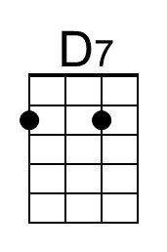
 |  |  |  |  |  |  |  | 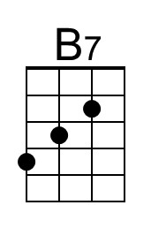
 |  |  |  |  |  |  | 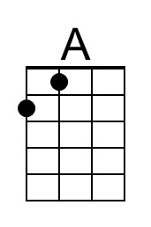 | 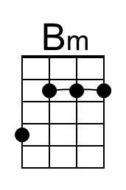
Baritone |  |  |  | 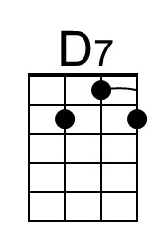 |  | 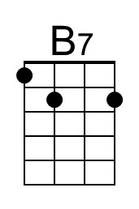
 | 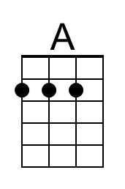 | 