**Have Yourself a Merry Little Christmas**

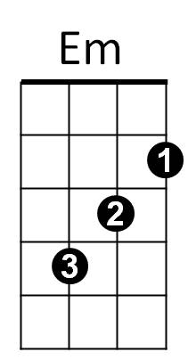

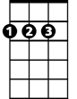

D

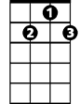

G7

E7

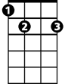

C

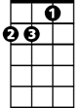

Dm

F



**Intro: C - F - Dm - G7**

**C Am Dm G7**

Have yourself a merry little Christmas,

**C Am Dm G7**

Let your heart be light,

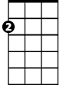

Am

**C Am Dm G7 E7 A7 D G7**

Next year all our troubles will be out of sight.

**C Am Dm G7**

Have yourself a merry little Christmas,

**C Am Dm G7**

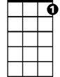

C7

Make the Yuletide gay,

**C Am Dm E7 C7**

Next year all our troubles will be miles away.

**F Em Dm G7 C**

Once again as in olden days happy golden days of yore,

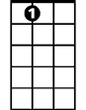

A7



G

**Am Em**

Faithful friends who are dear to us

**G D Dm G7**

Will be near to us once more.

**C Am Dm G7**

Someday soon we all will be together,

**C Am Dm G7**

If the Fates allow,

**C Am Dm G Am C7**

Until then we’ll have to muddle through somehow,

**F Dm G7 C F Dm C**

So have yourself a merry little Christmas now.

**F Dm G7 C F Dm C**

And have yourself a merry little Christ-mas now.

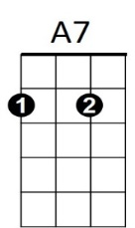

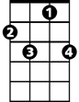

C7

**BARITONE**



G



F

C

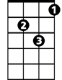

Dm



G7



Em



D



E7



Am