**Hawaii (Brian Wilson and Mike Love)**

**TACET**

Do you wanna go - **Straight to**

**Chorus:**

**G**

Hawaii, Hawaii

**Straight to** Hawaii

**Am**

Oh do (Honolulu, Waikiki) you -

**D G**

Wanna come along with me?

(do you wanna come along with me)

**C**

I heard about all the pretty girls,

**G**

With their grass skirts down to their knees

**Em A7**

All my life, I wanted to see,

**D TACET**

The island called Hawaii - Go to **-**

**(Chorus)**

**C**

Now I don’t know what town you’re from,

**G**

But don’t tell me that they got bigger waves

**Em**

**BARITONE**

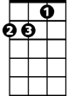

Am



G

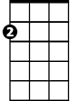

Em



D

Cause everyone that goes,

**A7 D TACET**

Comes back with nothing but raves- **That’s in**

**(Chorus)**

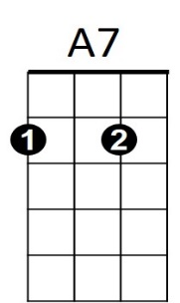**C**

And pretty soon this winter,

**G**

They’ll hold the surfing championship of the year

**Em**

Surfer guys and girls,

**A7 D TACET**

Will be coming from far and near - **Go to -**

**(Chorus)**

**Am**

Do you (Honolulu, Waikiki)

**D G**

Wanna come along with me

(do you wanna come along with me)

**Am**

Oo ooo oo (Honolulu, Waikiki)

**D G**

Oo oo oo (do you wanna come along with me)

Em

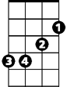

G



Am

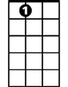

A7

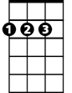

D