**Hawaiian Eyes (Jon Osorio & Randy Borden) Key C**

**Intro: C F G C**



G

F



C

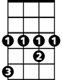

Ab

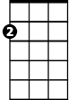

Am

**C F**

Often in the darkness

**G C**

Sometimes in the light

**F**

Visions of your golden eyes

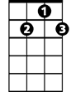

G7

**G C**

Sparkle in my sight

**Am Em**

Haunted by those graceful years

**Am Ab G G7**

When we were young and life was sharp and clear

**Chorus:**

**C F G C**

Can you see me now; Hawaiian eyes?

**F G C**

Can you see me lost in paradise?

**Am Em**

There were so many ways to go

**Am Em**

So many things to know

**F G (pause) C**

But I’ve missed you insi -de Hawaiian Eyes

**C F G C / C F G C**

**C F**

Shouting in the mountains

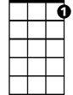

G7

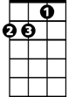

Am

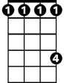

Ab

**BARITONE**



F



G

C



**G C**

Silent by the stream

**F**

Our eyes held each others’

**G C**

Locked in secret dreams

**Am Em**

Now we’re freed and drifting on

**Am Ab G G7**

Memories of you hover still and strong

**(Chorus) 2x**

**C F G C**

Ooo ---ooh, Hawaiian eyes