You Gotta Have Heart Richard Adler, Jerry Ross
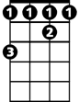
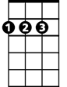
GCEA
F#
D
Start note F#
D Em7 A7 D C7 B7
You gotta have....heart All you really need is hea---art
Gm7 C9 C#dim D Bm7
When the odds are sayin' you'll never win That's when the grin should start
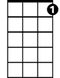
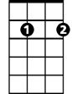
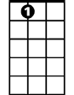
B7 Em7 A7 D C7 B7
You gotta have ho - ope, mustn't sit around and mope
GMaj7 C9 C#dim D Bm7
C7
Em7
A7
Nothin's half as bad as it may appear Wait'll next year and hope.
Am7 D7 GMaj7 Em7
When your luck is battin' zero, get your chin up off the floor.
Bm7 E7 A
Mister, you can be a hero, you can open any door.
Em7 A
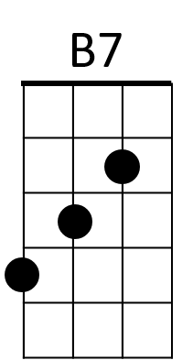
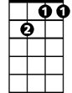
There's nothin' to it, but to do it
Gm7
Chorus 1
Em7 A7 D C7 B7
You've gotta have heart Miles and miles and miles of heart
GMaj7 C9 F#7
Oh, it's fine to be a genius of course But keep that ol' horse before the cart
Em7 A7 D
First you've got to have heart!
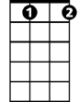
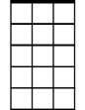
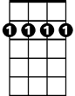
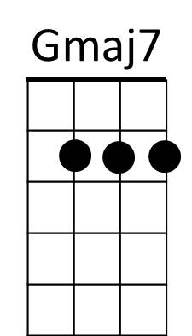
C#dim
Am7
Bm7
Option: end here and repeat from top
Extra material from script
Am7 D7
We're so happy, that we're hummin'.Hmm, Hmm, Hmm
GMaj7 Em7
That's the heart-y thing to do. Ho,ho,ho
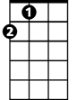
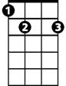
Bm7 E7
'Cause we know our ship will come in! Hmm, Hmm, Hmm
A
So it's ten years over due! Hoo, hoo, hoo.
A
E7
Em7 A7 D C7 B7
We’ve got have heart Miles and miles and miles of heart
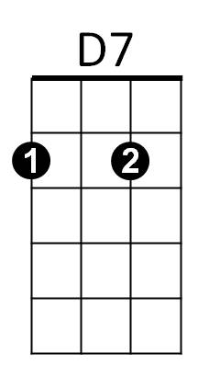
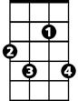
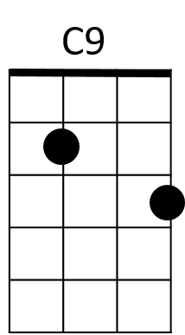
GMaj7 C9 F#7
Oh, it's fine to be a genius of course But keep that ol' horse before the cart
Em7 A7 D C7 B7
F#7
We've got hope We don't sit around and mope
GMaj7 Em7 D
Not a solitary sob do we heave, Mister, 'cause we've got hope
Em7 C9
*So what the heck's the use of cryin'? Why should we curse?
Bm7 B7
We've got to get better..........'cause we can't get worse!
Em7 A7
And to add to it;
A7 D A7 D A7 D A7 D
We’ve got heart We’ve got heart We’ve got heart!

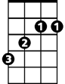
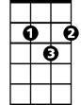
You Gotta Have Heart Richard Adler, Jerry Ross
F#
D
DGBE (Baritone)
Start note F#
D Em7 A7 D C7 B7
You gotta have....heart All you really need is hea---art
Gm7 C9 C#dim D Bm7
When the odds are sayin' you'll never win That's when the grin should start
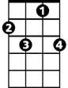
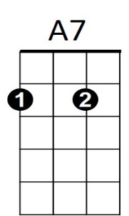
B7 Em7 A7 D C7 B7
You gotta have ho - ope, mustn't sit around and mope
GMaj7 C9 C#dim D Bm7
Em7
C7
Nothin's half as bad as it may appear Wait'll next year and hope.
Am7 D7 GMaj7 Em7
When your luck is battin' zero, get your chin up off the floor.
Bm7 E7 A
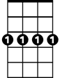
Mister, you can be a hero, you can open any door.
Em7 A
B7
Gm7
There's nothin' to it, but to do it
Chorus 1
Em7 A7 D C7 B7
You've gotta have heart Miles and miles and miles of heart
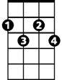
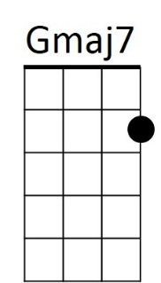
GMaj7 C9 F#7
Oh, it's fine to be a genius of course But keep that ol' horse before the cart
Em7 A7 D
Bm7
C#dim
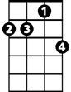
First you've got to have heart!
Am7

Option: end here and repeat from top
Extra material from script
Am7 D7
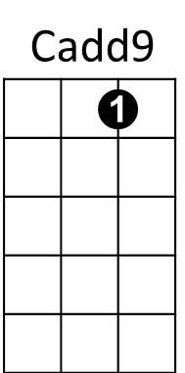
We're so happy, that we're hummin'.Hmm, Hmm, Hmm
GMaj7 Em7
That's the heart-y thing to do. Ho,ho,ho
A
E7
Bm7 E7
'Cause we know our ship will come in! Hmm, Hmm, Hmm
A
So it's ten years over due! Hoo, hoo, hoo.
Em7 A7 D C7 B7
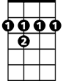
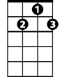
We’ve got have heart Miles and miles and miles of heart
F#7
D7
GMaj7 C9 F#7
Oh, it's fine to be a genius of course But keep that ol' horse before the cart
Em7 A7 D C7 B7
We've got hope We don't sit around and mope
GMaj7 Em7 D
Not a solitary sob do we heave, Mister, 'cause we've got hope
Em7 C9
*So what the heck's the use of cryin'? Why should we curse?
Bm7 B7
We've got to get better..........'cause we can't get worse!
Em7 A7
And to add to it;
A7 D A7 D A7 D A7 D
We’ve got heart We’ve got heart We’ve got heart!
https://www.youtube.com/watch?v=Ry8CpIg2fvU scene from movie
https://www.doctoruke.com/yougottahaveheart.pdf - lyrics chords

*Tabs for irregular melody:

Em7 C9
E string 2 3 5 7 0 0 0 0 0 6 0 0 0
So what the heck’s the use of cryin’, why should we curse

Bm7 B7 Em7 A7
7 7 2 2 2 2 5 7 9 5 5 7 9 10 9 7
We got-ta get better cause we can’t get worse, and to add to it

A7 D A7 D A7 D
9 9 10 9 9 10 9 9 11- 10
We’ve got heart, we’ve got heart, we’ve got he-art

Modified lower version of line 2

Bm7 B7 Em7 A7
7 7 2 2 2 2 5 7 9 5 5 3 5 7 5 3 3 3 5
We got-ta get better cause we can’t get worse, and to add to it we’ve got heart

Whole script of scene from movie

https://www.ceder.net/recorddb/lyrics_viewsingle.php?LyricsId=2293&menu=0

Coach:
[Spoken]
See boys, that's what I'm talking about. Baseball is only one half skill
The other half is something else.....something bigger!
You've gotta have....heart
All you really need is heart
When the odds are sayin' you'll never win
That's when the grin should start
You've gotta have hope, mustn't sit around and mope
Nothin' half as bad as it may appear
Wait'll next year and hope.
When your luck is battin' zero, get your chin up off the floor.
Mister, you can be a hero, you can open any door.
There's nothin' to it, but to do it
You've gotta have heart
Miles and miles and miles of heart
Oh, it's fine to be a genius of course
But keep that ol' horse before the cart
First you've got to have heart!
Rocky:
A great slugger, we haven't got!
Smokey:
A great pitcher, we haven't got!
Sohovic:
A great ball clue, we haven't got!
All:
What've we got?
We've got heart
All you really need is heart
When the odds are sayin', you'll never win
That's when the grin should start
We've got hope
We don't sit around and mope
Not a solitary sob do we heave
Mister 'cause we've got hope.
Rocky:
We're so happy, that we're hummin'.
All:
Hmm, Hmm, Hmm
Coach:
That's the heart-y thing to do.
Smokey:
'Cause we know our ship will come in!
All:
Hmm, hmm, hmm
Sohovic:
So it's ten years over due!
All:
Hoo, hoo, hoo.
We've got heart
Miles and miles and miles of heart
Oh it's fine to be a genius of course
But keep that old horse before the cart
Smokey:
So what the heck's the use of cryin'?
Coach:
Why should we curse?
Sohovic:
We've got to get better......
Rocky:
....'cause we can't get worse!
All:
And to add to it; we've got heart
We've got heart
We've got heart!

