Heart And Soul (Frank Loesser & Hoagy Carmichael, 1938) (C)
Heart And Soul by Larry Clinton & his Orchestra featuring Helen Ward (1938)
Heart and Soul by the Four Aces (1952) – Heart and Soul by Crystal Gayle
Version 2 4/4 Time – 90 bpm
C-Tuning Chords
Intro C | Am7 | Dm7 | G7 |  C Am7 - Dm7 G7  Heart and soul, I fell in love with you,  C Am7 - Dm7 G7 C Am Dm  Heart and soul, the way a fool would do. Madly...  G7 C - Am7 Dm7 G7  Because you held me tight, and stole a kiss in the night.  C Am7 - Dm7 G7  Heart and soul, I begged to be adored,  C Am7 - Dm7 G7 C Am Dm  Lost con-trol, and tumbled overboard. Gladly...  G7 C - C7  That magic night we kissed, there in the moon mist.  Bridge  F E7 A7 D7 G7 C7 B7 E7  _ Oh! but your lips were thril-ling, much too thril - ling,  F E7 A7 D7 G7 C7 B7 G7  _ Never be-fore were mine so strange - ly wil - ling.  C Am7 - Dm7 G7  But now I see, what one em-brace can do,  C Am7 - Dm7 G7 C Am Dm7  Look at me, it's got me loving you, madly...  _______________________________________________  │ 1. G7 E7 A7 Dm  │ That little kiss you stole,  │ D9 G7 C Am7 Dm7 G7  │ held all my heart and soul. Repeat from Top  _______________________________________________  │ 2. G7 E7 A7 Dm  │ That little kiss you stole,  │ D9 G7 C Am7 Dm7 G7b9 C  │ held all my heart and soul. | 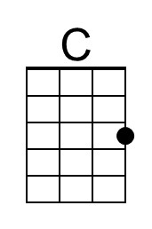 | 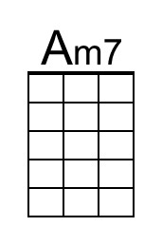
 | 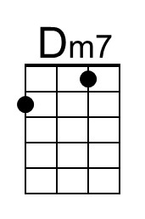 | 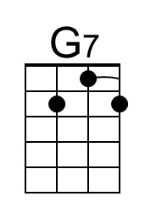
 | 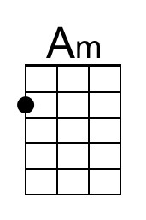 | 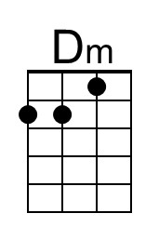
 | 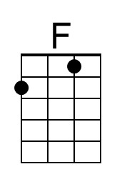 | 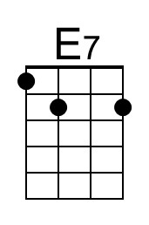
 | 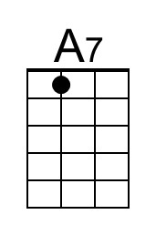 | 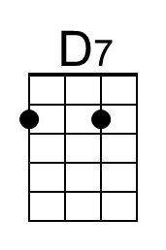
 | 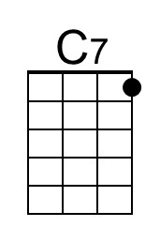 | 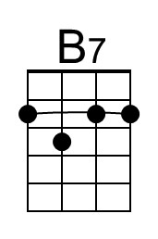
 | 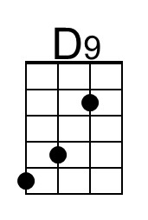 | 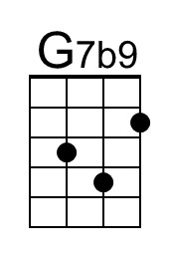

Heart And Soul (Frank Loesser & Hoagy Carmichael, 1938) (C)
Heart And Soul by Larry Clinton & his Orchestra featuring Helen Ward (1938)
Heart and Soul by the Four Aces (1952) – Heart and Soul by Crystal Gayle
Version 2 4/4 Time – 90 bpm
G-Tuning Chords
Intro C | Am7 | Dm7 | G7 |  C Am7 - Dm7 G7  Heart and soul, I fell in love with you,  C Am7 - Dm7 G7 C Am Dm  Heart and soul, the way a fool would do. Madly...  G7 C - Am7 Dm7 G7  Because you held me tight, and stole a kiss in the night.  C Am7 - Dm7 G7  Heart and soul, I begged to be adored,  C Am7 - Dm7 G7 C Am Dm  Lost con-trol, and tumbled overboard. Gladly...  G7 C - C7  That magic night we kissed, there in the moon mist.  Bridge  F E7 A7 D7 G7 C7 B7 E7  _ Oh! but your lips were thril-ling, much too thril - ling,  F E7 A7 D7 G7 C7 B7 G7  _ Never be-fore were mine so strange - ly wil - ling.  C Am7 - Dm7 G7  But now I see, what one em-brace can do,  C Am7 - Dm7 G7 C Am Dm7  Look at me, it's got me loving you, madly...  _______________________________________________  │ 1. G7 E7 A7 Dm  │ That little kiss you stole,  │ D9 G7 C Am7 Dm7 G7  │ held all my heart and soul. Repeat from Top  _______________________________________________  │ 2. G7 E7 A7 Dm  │ That little kiss you stole,  │ D9 G7 C Am7 Dm7 G7b9 C  │ held all my heart and soul. | 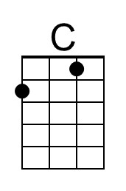 | 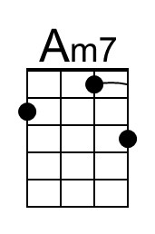
 | 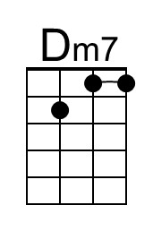 | 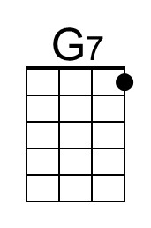
 | 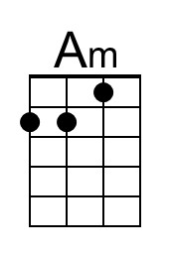 | 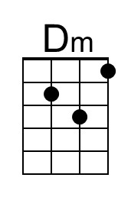
 | 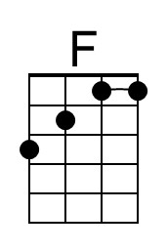 | 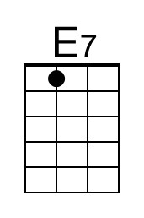
 | 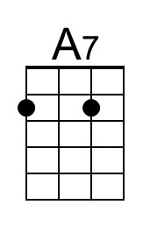 | 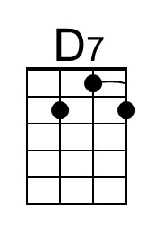
 | 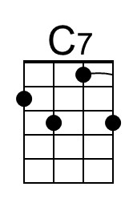 | 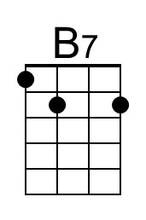
 | 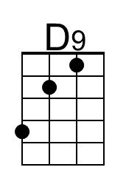 | 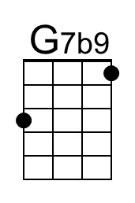

Heart And Soul (Frank Loesser & Hoagy Carmichael, 1938) (G)
Heart And Soul by Larry Clinton & his Orchestra featuring Helen Ward (1938)
Heart and Soul by the Four Aces (1952) – Heart and Soul by Crystal Gayle
Version 2 4/4 Time – 90 bpm
C-Tuning Chords
Intro G | Em7 | Am7 | D7 |  G Em7 - Am7 D7  Heart and soul, I fell in love with you,  G Em7 - Am7 D7 G Em Am  Heart and soul, the way a fool would do. Madly...  D7 G - Em7 Am7 D7  Because you held me tight, and stole a kiss in the night.  G Em7 - Am7 D7  Heart and soul, I begged to be adored,  G Em7 - Am7 D7 G Em Am  Lost con-trol, and tumbled overboard. Gladly...  D7 G - G7  That magic night we kissed, there in the moon mist.  Bridge  C B7 E7 A7 D7 G7 F#7 B7  _ Oh! but your lips were thril-ling, much too thril - ling,  C B7 E7 A7 D7 G7 F#7 D7  _ Never be-fore were mine so strange - ly wil - ling.  G Em7 - Am7 D7  But now I see, what one em-brace can do,  G Em7 - Am7 D7 G Em Am7  Look at me, it's got me loving you, madly...  _______________________________________________  │ 1. D7 B7 E7 Am  │ That little kiss you stole,  │ A9 D7 G Em7 Am7 D7  │ held all my heart and soul. Repeat from Top  _______________________________________________  │ 2. D7 B7 E7 Am  │ That little kiss you stole,  │ A9 D7 G Em7 Am7 D7b9 G  │ held all my heart and soul. | 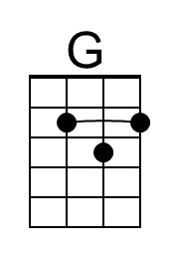 | 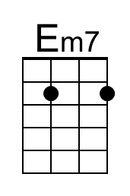
 | 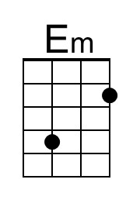
 |  | 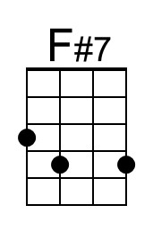
 | 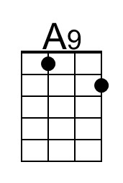 | 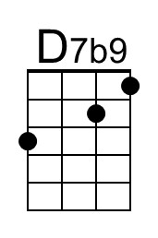

Heart And Soul (Frank Loesser & Hoagy Carmichael, 1938) (G)
Heart And Soul by Larry Clinton & his Orchestra featuring Helen Ward (1938)
Heart and Soul by the Four Aces (1952) – Heart and Soul by Crystal Gayle
Version 2 4/4 Time – 90 bpm
G-Tuning Chords
Intro G | Em7 | Am7 | D7 |  G Em7 - Am7 D7  Heart and soul, I fell in love with you,  G Em7 - Am7 D7 G Em Am  Heart and soul, the way a fool would do. Madly...  D7 G - Em7 Am7 D7  Because you held me tight, and stole a kiss in the night.  G Em7 - Am7 D7  Heart and soul, I begged to be adored,  G Em7 - Am7 D7 G Em Am  Lost con-trol, and tumbled overboard. Gladly...  D7 G - G7  That magic night we kissed, there in the moon mist.  Bridge  C B7 E7 A7 D7 G7 F#7 B7  _ Oh! but your lips were thril-ling, much too thril - ling,  C B7 E7 A7 D7 G7 F#7 D7  _ Never be-fore were mine so strange - ly wil - ling.  G Em7 - Am7 D7  But now I see, what one em-brace can do,  G Em7 - Am7 D7 G Em Am7  Look at me, it's got me loving you, madly...  _______________________________________________  │ 1. D7 B7 E7 Am  │ That little kiss you stole,  │ A9 D7 G Em7 Am7 D7  │ held all my heart and soul. Repeat from Top  _______________________________________________  │ 2. D7 B7 E7 Am  │ That little kiss you stole,  │ A9 D7 G Em7 Am7 D7b9 G  │ held all my heart and soul. | 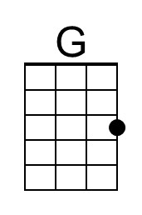 | 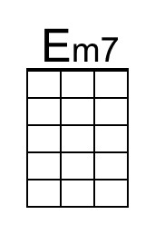
 | 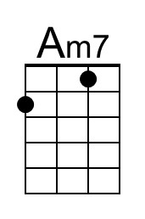
 | 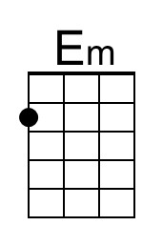
 | 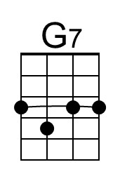 | 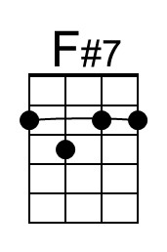
 | 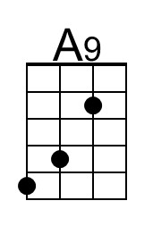 | 