**Heart Like a Wheel (Kate and Anna McGarrigle)**

**Intro: F G G7 C**

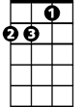

Dm

F



Em

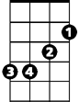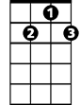

G7



G



C

**C G**

Some say a heart is just like a wheel,

**Em Am**

When you bend it, you can't mend it.

**Dm Am Dm**

And my love for you is like a sinking ship

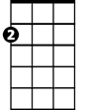

Am

**F G G7 C**

And my heart is on that ship out in mid o - cean.

**F G G7 C**

**C G**

They say that death is a tragedy;

**Em Am**

It comes once and it's over.

**Dm Am Dm**

But my only wish is for that deep dark abyss,

**F G G7 C**

'Cause what's the use of living with no true lo - ver?

**F G G7 C**

**C G**

When harm is done no love can be won,

**BARITONE**

**Em Am**

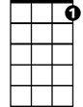

G7



G



F

I know it happens frequently.

**Dm Am Dm**

What I can't understand, Oh please God hold my hand,

**F G G7 C**

Why it had to happen to me - e.

**Refrain:**



Am



Em

C



**Am Dm G**

And it's only love, and it's only love.

**Am Dm G G7**

That can wreck a human being and turn him inside out

**Instrumental Verse**

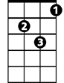

Dm

**C G**

Some say a heart is just like a wheel,

**Em Am**

When you bend it, you can't mend it.

**Dm Am Dm**

And my love for you is like a sinking ship

**F G G7 C**

And my heart is on that ship out in mid o - cean

**F G G7 C F C**

**Heart Like a Wheel (Kate and Anna McGarrigle)**

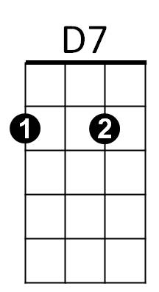**Intro: C D D7 G**



G

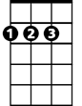

D



C

**G D**

Some say a heart is just like a wheel,

**Bm Em**

When you bend it, you can't mend it.

**Am Em Am**

And my love for you is like a sinking ship

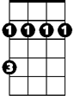

Bm

Em



Am

**C D D7 G**

And my heart is on that ship out in mid o - cean.

**C D D7 G**

**G D**

They say that death is a tragedy;

**Bm Em**

It comes once and it's over.

**Am Em Am**

But my only wish is for that deep dark abyss,

**C D D7 G**

'Cause what's the use of living with no true lo - ver?

**C D D7 G**

**G D**

When harm is done no love can be won,

**BARITONE**

**Bm Em**

C



D



D7

I know it happens frequently.

**Am Em Am**

What I can't understand, Oh please God hold my hand,

**C D D7 G**

Why it had to happen to me - e.

**Refrain:**



Em

Bm



G

**Em Am D**

And it's only love, and it's only love.

**Em Am D D7**

That can wreck a human being and turn him inside out

**Instrumental Verse**



Am

**G D**

Some say a heart is just like a wheel,

**Bm Em**

When you bend it, you can't mend it.

**Am Em Am**

And my love for you is like a sinking ship

**C D D7 G**

And my heart is on that ship out in mid o - cean

**C D D7 G C G**