Heart of Gold (Neil Young) by Neil Young

Intro: Em / / / / / / D/ / Em / 2x (harmonica optional)
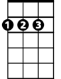
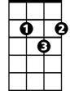
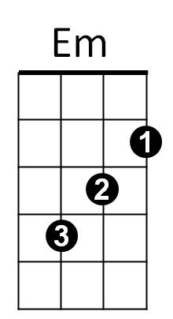
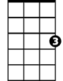
D
G
C
Em C D G
I wanna live, I wanna give
Em C D G
I've been a miner for a heart of gold
Em C D G
It's these expressions I never give

Chorus:
Em G
That keep me searchin' for a heart of gold
C C/ / / - G / or (Em/ D/ C/ G )
And I'm gettin' old Tabs: C string - 4 2 0 - G
Em G
Keep me searchin' for a heart of gold
C C / / / - G / or ( Em/ D/ C/ G )
And I'm gettin' old Tabs: C string - 4 2 0 - G

Em C D G
I've been to Hollywood, I've been to Redwood
Em C D G
I crossed the ocean for a heart of gold
Em C D G
I've been in my mind it's such a fine line

(Chorus)

C / / - / / / Tabs: C string - 4 2 0 - G (optional harmonica interlude)
BARITONE
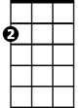
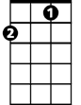
Em D Em
G
D
Em
C
Keep me searchin' for a heart of gold
Em D Em
You keep me searchin' and I'm growin' old
Em D Em
Keep me searchin' for a heart of gold
Em G
I've been a miner for a heart of gold
C C / / / - G / or Em/ D/ C/ - G/ (or TABS: C string - 4 2 0 – G)
Ahh ahhhh

