**Heart of Gold (Neil Young)**

**Intro: Em ////// D // Em / (3x)**

**Em G C G Em ////// D // Em /**

**Em C D G Em**

I want to live, I want to give

**C D G Em**

I've been a miner for a heart of gold

**C D G Em**

It's these expressions I never give

**G**

That keep me searchin' for a heart of gold

**C G**

And I'm gettin' old

**Em G**

Keeps me searchin’ for a heart of gold

**C G**

And I'm gettin' old

**Em ////// D // Em /**

**Em C D G Em**

**BARITONE**

I've been to Hollywood, I've been to Redwood

**C D G Em**

I crossed the ocean for a heart of gold

**C D G Em**

I've been in my mind, it's such a fine line

**G**

That keeps me searching for a heart of gold

**C G**

And I'm getting old

**Em G**

Keeps me searchin’ for a heart of gold

**C G**

And I'm gettin' old

**G D Am G / G Am C G / G D G**

**Em D Em**

Keep me searchin’ for a heart of gold

**D Em**

You keep me searchin’ and I'm growin’ old

**D Em**

Keep me searchin’ for a heart of gold

**G C G**

I've been a miner for a heart of gold... Ahh ahhhh

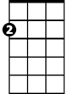

Em



D



G

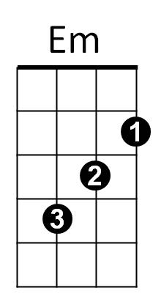



C



Am



G

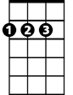

D

C

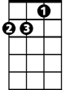

Am