**Hello Mary Lou (Cayet Mangiaracina / Gene Pitney) Key C**

**Chorus:**

F



G

**C F**



C

**BARITONE**

Hello Mary Lou, Goodbye heart

**C G G7**

Sweet Mary Lou, I'm so in love with you

**C E7 Am**

I knew Mary Lou, we'd never part

**C G C F C**

So hello Mary Lou, Goodbye heart"

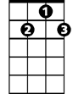

G7

E7

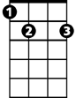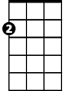

Am

**C**

You passed me by one sunny day

**F**

Flashed those big brown eyes my way

**C G**

And ooh I wanted you forever more

**C**

Now I'm not one that gets around

**F**

I swear my feet stuck to the ground

**C G C F C**

And though I never did meet you before - I said

**(Chorus)**

**C**



G



F

C



I saw your lips I heard your voice

**F**

Believe me I just had no choice

**C G**

Wild horses couldn't make me stay away

**C**

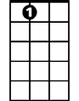

E7

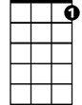

G7

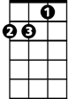

Am

I thought about a moonlit night

**F**

My arms around you, good an' tight

**C G C F C**

That’s all I had to see for me to say – hey hey

**(Chorus)**

**C G C F C**

So hello Mary Lou, Goodbye heart"

**C G C F C**

Yes, hello Mary Lou, Goodbye heart"

**Hello Mary Lou (Cayet Mangiaracina / Gene Pitney) Key G**

**Chorus:**

**G C**

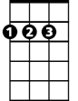

D



C



G

Hello Mary Lou, Goodbye heart

**G D D7**

Sweet Mary Lou, I'm so in love with you

**G B7 Em**

I knew Mary Lou, we'd never part

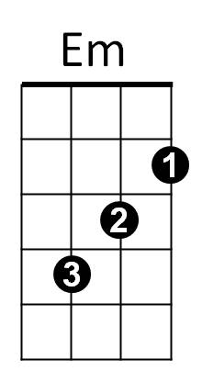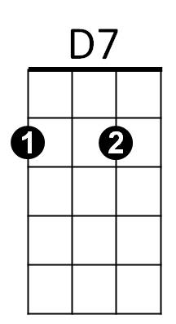 **G D G C G**

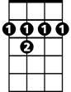

B7

So hello Mary Lou, Goodbye heart"

**G**

You passed me by one sunny day

**C**

Flashed those big brown eyes my way

**G D**

And ooh I wanted you forever more

**G**

Now I'm not one that gets around

**C**

I swear my feet stuck to the ground

**G D G C G**

And though I never did meet you before - I said

**(Chorus)**

**BARITONE**

**G**



G



D

C



I saw your lips I heard your voice

**C**

Believe me I just had no choice

**G D**

Wild horses couldn't make me stay away

**G**

B7



I thought about a moonlit night



Em



D7

**C**

My arms around you, good an' tight

**G D G C G**

That’s all I had to see for me to say – hey hey

**(Chorus)**

**G D G C G**

So hello Mary Lou, Goodbye heart"

**G D G C G**

Yes, hello Mary Lou, Goodbye heart"

**Hello Mary Lou (Cayet Mangiaracina / Gene Pitney) Key F**

**Chorus:**

**F Bb**

Hello Mary Lou, Goodbye heart

**F C C7**

Sweet Mary Lou, I'm so in love with you



A7



C7



Dm



C



Bb

F



**F A7 Dm**

I knew Mary Lou, we'd never part

**F C F Bb F**

So hello Mary Lou, Goodbye heart"

**F**

You passed me by one sunny day

**Bb**

Flashed those big brown eyes my way

**F C**

And ooh I wanted you forever more

**F**

Now I'm not one that gets around

**Bb**

I swear my feet stuck to the ground

**F C F Bb F**

And though I never did meet you before - I said

**(Chorus)**

**F**

I saw your lips I heard your voice

**Bb**

Believe me I just had no choice

**F C**

Wild horses couldn't make me stay away

**BARITONE**

**F**

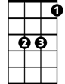

Bb



F

C



I thought about a moonlit night

**Bb**

My arms around you, good an' tight

**F C F Bb F**

That’s all I had to see for me to say – hey hey

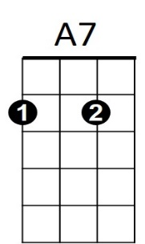

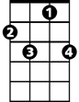

C7

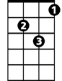

Dm

**(Chorus)**

**F C F Bb F**

So hello Mary Lou, Goodbye heart"

**F C F Bb F**

Yes, hello Mary Lou, Goodbye heart"