Hello Muddah, Hello Fadduh (Allan Sherman, 1963) (C)
Music from Ponchielli's "Dance of the Hours" from La Gioconda – GCEA

Intro C | G7 | C G7 | C  C G7  Hello muddah hello faddah  C  Here I am at Camp Gre-nada  B7 Em  Camp is very enter-taining  A7 G  And they say we'll have some fun  D7 G7  If it stops raining.  C G7  I went hiking with Joe Spivey,  C  He developed poison ivy.  E7 F  You re-member Leonard Skinner?  C  He got ptomaine poisoning  G7 C  Last night after dinner.  C G7  All the counselors hate the waiters  C  And the lake has alli-gators  B7 Em  And the head coach wants no sissies  A7 G  So he reads to us from  D7 G7  Something called U-lysses.  C G7  Now I don’t want this should scare ya  C  But my bunk mate has ma-laria  E7 F  You re-member Jeffrey Hardy?  C G7  They're a-bout to organ-ize  C  A searching party. | Bridge  Cm Fm6  Take me home, oh muddah, faddah.  Cm Fm  Take me home. I hate Grenada.  Cm Eb  Don’t leave me out in the forest  Ab Eb G7  Where I might get eaten by a bear.  Cm Fm6  Take me home. I promise I will  Cm Fm  Not make noise or mess the house  Cm Eb  With other boys oh please  Ab  Don't make me stay  Dm7 G7  I've been here one whole day.  C G7  Dearest faddah, darling muddah  C  How's my precious little bruddah?  B7 Em  Let me come home if you miss me  A7 G  I would even let Aunt  D7 G  Bertha hug and kiss me.  C G7  Wait a minute, it's stopped hailing.  C  Guys are swimming, guys are sailing.  E7 F  Playing baseball, gee that’s better.  C  Muddah, faddah kindly  G7 C | C G7 | C  Disregard this letter. | 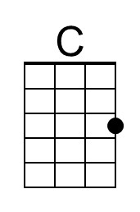 | 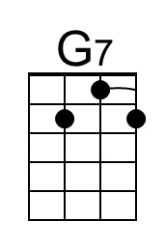
 |  | 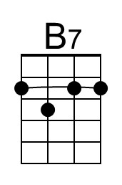 | 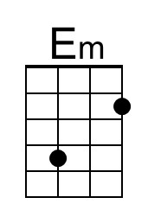
 |  | 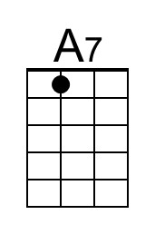 | 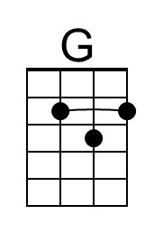
 |  | 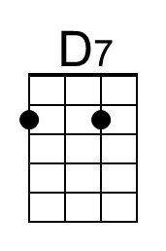 | 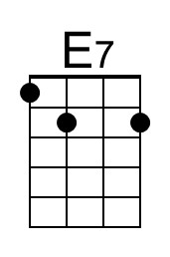
 |  | 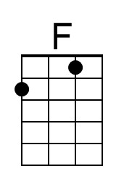 | 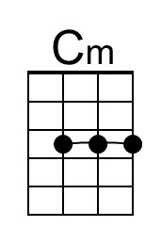
 |  | 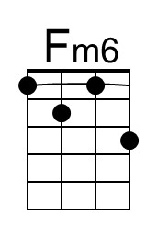 | 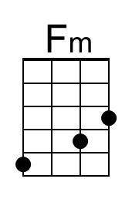
 |  | 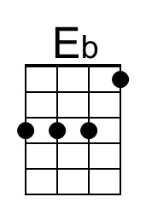 | 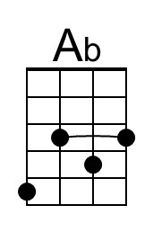
 |  | 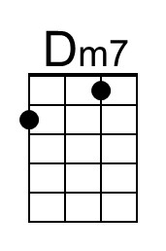

Hello Muddah, Hello Fadduh (Allan Sherman, 1963) (C)
Music from Ponchielli's "Dance of the Hours" from La Gioconda – DGBE

Intro C | G7 | C G7 | C  C G7  Hello muddah hello faddah  C  Here I am at Camp Gre-nada  B7 Em  Camp is very enter-taining  A7 G  And they say we'll have some fun  D7 G7  If it stops raining.  C G7  I went hiking with Joe Spivey,  C  He developed poison ivy.  E7 F  You re-member Leonard Skinner?  C  He got ptomaine poisoning  G7 C  Last night after dinner.  C G7  All the counselors hate the waiters  C  And the lake has alli-gators  B7 Em  And the head coach wants no sissies  A7 G  So he reads to us from  D7 G7  Something called U-lysses.  C G7  Now I don’t want this should scare ya  C  But my bunk mate has ma-laria  E7 F  You re-member Jeffrey Hardy?  C G7  They're a-bout to organ-ize  C  A searching party. | Bridge  Cm Fm6  Take me home, oh muddah, faddah.  Cm Fm  Take me home. I hate Grenada.  Cm Eb  Don’t leave me out in the forest  Ab Eb G7  Where I might get eaten by a bear.  Cm Fm6  Take me home. I promise I will  Cm Fm  Not make noise or mess the house  Cm Eb  With other boys oh please  Ab  Don't make me stay  Dm7 G7  I've been here one whole day.  C G7  Dearest faddah, darling muddah  C  How's my precious little bruddah?  B7 Em  Let me come home if you miss me  A7 G  I would even let Aunt  D7 G  Bertha hug and kiss me.  C G7  Wait a minute, it's stopped hailing.  C  Guys are swimming, guys are sailing.  E7 F  Playing baseball, gee that’s better.  C  Muddah, faddah kindly  G7 C | C G7 | C  Disregard this letter. | 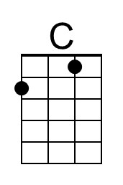 | 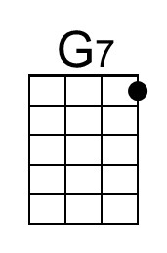
 |  | 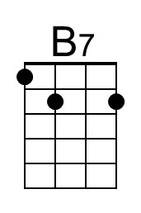 | 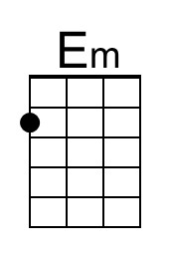
 |  | 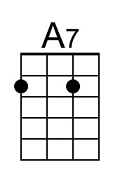 | 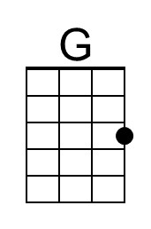
 |  | 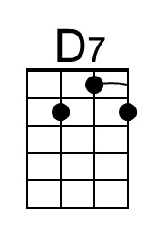 | 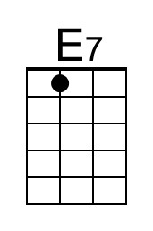
 |  | 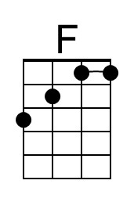 | 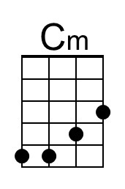
 |  | 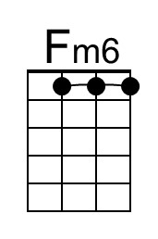 | 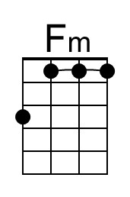
 |  | 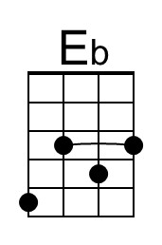 | 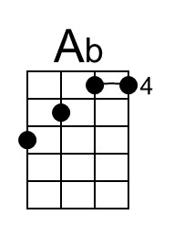
 |  | 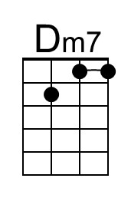

Hello Muddah, Hello Fadduh (Allan Sherman, 1963) (G)
Music from Ponchielli's "Dance of the Hours" from La Gioconda – GCEA

Intro G | D7 | G D7 | G  G D7  Hello muddah hello faddah  G  Here I am at Camp Gre-nada  F#7 Bm  Camp is very enter-taining  E7 D  And they say we'll have some fun  A7 D7  If it stops raining.  G D7  I went hiking with Joe Spivey,  G  He developed poison ivy.  B7 C  You re-member Leonard Skinner?  G  He got ptomaine poisoning  D7 G  Last night after dinner.  G D7  All the counselors hate the waiters  G  And the lake has alli-gators  F#7 Bm  And the head coach wants no sissies  E7 D  So he reads to us from  A7 D7  Something called U-lysses.  G D7  Now I don’t want this should scare ya  G  But my bunk mate has ma-laria  B7 C  You re-member Jeffrey Hardy?  G D7  They're a-bout to organ-ize  G  A searching party. | Bridge  Gm Cm6  Take me home, oh muddah, faddah.  Gm Cm  Take me home. I hate Grenada.  Gm Bb  Don’t leave me out in the forest  Eb Bb D7  Where I might get eaten by a bear.  Gm Cm6  Take me home. I promise I will  Gm Cm  Not make noise or mess the house  Gm Bb  With other boys oh please  Eb  Don't make me stay  Am7 D7  I've been here one whole day.  G D7  Dearest faddah, darling muddah  G  How's my precious little bruddah?  F#7 Bm  Let me come home if you miss me  E7 D  I would even let Aunt  A7 D  Bertha hug and kiss me.  G D7  Wait a minute, it's stopped hailing.  G  Guys are swimming, guys are sailing.  B7 C  Playing baseball, gee that’s better.  G  Muddah, faddah kindly  D7 G | G D7 | G  Disregard this letter.
 |  | 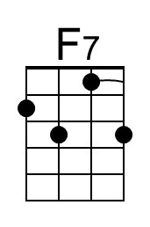 | 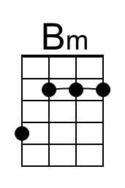
 |  |  | 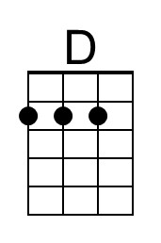
 |  |  | 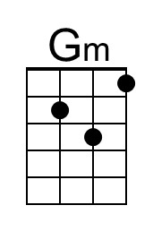
 |  | 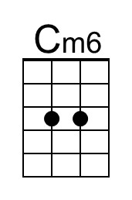
 |  | 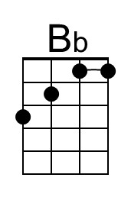
 |  | 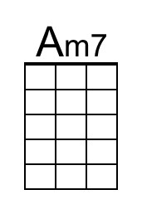

Hello Muddah, Hello Fadduh (Allan Sherman, 1963) (G)
Music from Ponchielli's "Dance of the Hours" from La Gioconda – DGBE

Intro G | D7 | G D7 | G  G D7  Hello muddah hello faddah  G  Here I am at Camp Gre-nada  F#7 Bm  Camp is very enter-taining  E7 D  And they say we'll have some fun  A7 D7  If it stops raining.  G D7  I went hiking with Joe Spivey,  G  He developed poison ivy.  B7 C  You re-member Leonard Skinner?  G  He got ptomaine poisoning  D7 G  Last night after dinner.  G D7  All the counselors hate the waiters  G  And the lake has alli-gators  F#7 Bm  And the head coach wants no sissies  E7 D  So he reads to us from  A7 D7  Something called U-lysses.  G D7  Now I don’t want this should scare ya  G  But my bunk mate has ma-laria  B7 C  You re-member Jeffrey Hardy?  G D7  They're a-bout to organ-ize  G  A searching party. | Bridge  Gm Cm6  Take me home, oh muddah, faddah.  Gm Cm  Take me home. I hate Grenada.  Gm Bb  Don’t leave me out in the forest  Eb Bb D7  Where I might get eaten by a bear.  Gm Cm6  Take me home. I promise I will  Gm Cm  Not make noise or mess the house  Gm Bb  With other boys oh please  Eb  Don't make me stay  Am7 D7  I've been here one whole day.  G D7  Dearest faddah, darling muddah  G  How's my precious little bruddah?  F#7 Bm  Let me come home if you miss me  E7 D  I would even let Aunt  A7 D  Bertha hug and kiss me.  G D7  Wait a minute, it's stopped hailing.  G  Guys are swimming, guys are sailing.  B7 C  Playing baseball, gee that’s better.  G  Muddah, faddah kindly  D7 G | G D7 | G  Disregard this letter.
 |  | 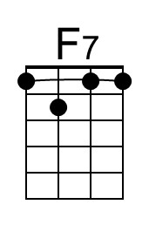 | 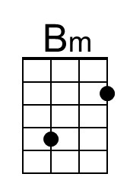
 |  |  | 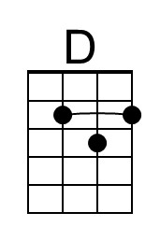
 |  |  | 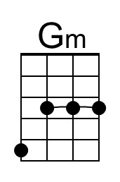
 |  | 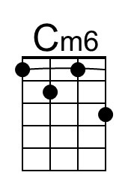
 |  | 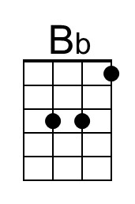
 |  | 