
Here Comes Santa Claus
C08 C
(Gene Autry & Oakley Haldeman, 1947) – Here Comes Santa Claus by Gene Autry
Intro Last line of verse + G7  C G7  Here comes Santa Claus, here comes Santa Claus, right down Santa Claus Lane.  C C7  Vixen and Blitzen and all his reindeer are pulling on the rein.  F Em Dm G7 C  Bells are ringing, children singing, all is merry and bright.  F C A7 Dm G7 C  Hang your stockings and say your prayers, 'Cause Santa Claus comes to-night.  C G7  Here comes Santa Claus, here comes Santa Claus, right down Santa Claus Lane.  C C7  He's got a bag that is filled with toys for the boys and girls a-gain.  F Em Dm G7 C  Hear those sleigh bells jingle jangle, what a beautiful sight.  F C A7 Dm G7 C  Jump in bed, cover up your head, 'Cause Santa Claus comes to-night.  C G7  Here comes Santa Claus, here comes Santa Claus, right down Santa Claus Lane.  C C7  He doesn’t care if you’re rich or poor, he loves you just the same  F Em Dm G7 C  Santa Claus knows that we’re all God’s children, that makes everything right  F C A7 Dm G7 C  So fill your hearts with Christmas cheer, 'cause Santa Claus comes to-night.  C G7  Here comes Santa Claus, here comes Santa Claus, right down Santa Claus Lane.  C C7  He'll come around when chimes ring out, it's Christmas time again  F Em Dm G7 C  Peace on earth will come to all, if we just follow the light  F C A7 Dm G7 C G7  So let's give thanks to the Lord above, 'cause Santa Claus comes to-night.  Repeat First Verse  Outro  A7 Dm G7 C  Tonight, Santa Claus comes to-night. |  |  |  |  |  |  |  | 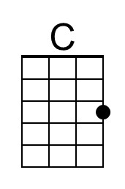
 |  |  |  |  |  |  |  | 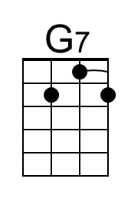
 |  |  |  |  |  |  |  | 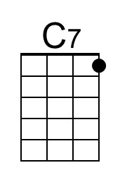
 |  |  |  |  |  |  |  | 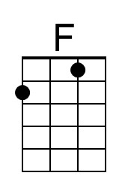
 |  |  |  |  |  |  |  | 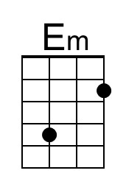
 |  |  |  |  |  |  |  | 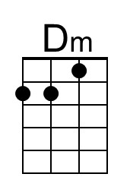
 |  |  |  |  |  |  |  | 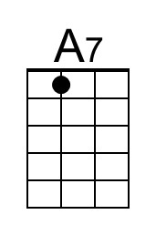
Baritone | 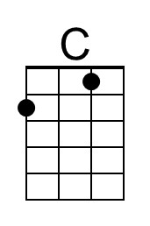 | 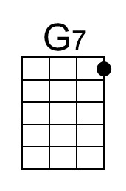 | 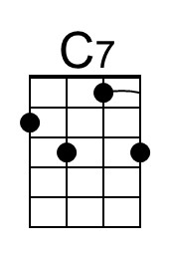 | 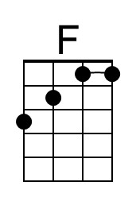 | 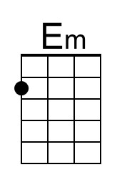 | 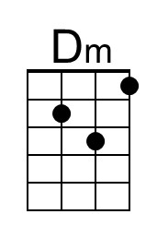 | 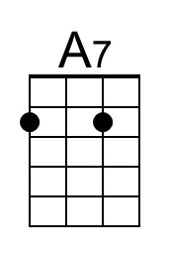

Here Comes Santa Claus
C08 G
(Gene Autry & Oakley Haldeman, 1947) – Here Comes Santa Claus by Gene Autry
Intro Last line of verse + D7  G D7  Here comes Santa Claus, here comes Santa Claus, right down Santa Claus Lane.  G G7  Vixen and Blitzen and all his reindeer are pulling on the rein.  C Bm Am D7 G  Bells are ringing, children singing, all is merry and bright.  C G E7 Am D7 G  Hang your stockings and say your prayers, 'Cause Santa Claus comes to-night.  G D7  Here comes Santa Claus, here comes Santa Claus, right down Santa Claus Lane.  G G7  He's got a bag that is filled with toys for the boys and girls a-gain.  C Bm Am D7 G  Hear those sleigh bells jingle jangle, what a beautiful sight.  C G E7 Am D7 G  Jump in bed, cover up your head, 'Cause Santa Claus comes to-night!  G D7  Here comes Santa Claus, here comes Santa Claus, right down Santa Claus Lane.  G G7  He doesn’t care if you’re rich or poor, he loves you just the same  C Bm Am D7 G  Santa Claus knows that we’re all God’s children, that makes everything right  C G E7 Am D7 G  So fill your hearts with Christmas cheer, 'cause Santa Claus comes to-night  G D7  Here comes Santa Claus, here comes Santa Claus, right down Santa Claus Lane.  G G7  He'll come around when chimes ring out, it's Christmas time again  C Bm Am D7 G  Peace on earth will come to all, if we just follow the light  C G E7 Am D7 G D7  So let's give thanks to the Lord above, 'cause Santa Claus comes to-night.  Repeat First Verse  Outro  E7 Bm D7 G  Tonight. Santa Claus comes to-night. |  |  |  |  |  |  |  | 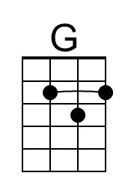
 |  |  |  |  |  |  |  | 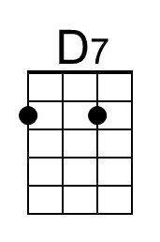
 |  |  |  |  |  |  |  | 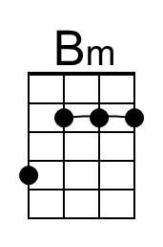
 |  |  |  |  |  |  |  | 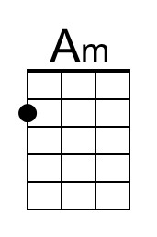
 |  |  |  |  |  |  |  | 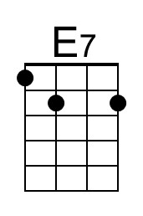
Baritone | 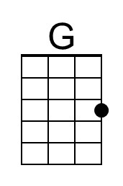 | 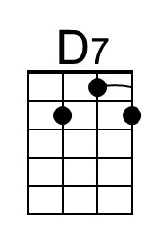 |  |  | 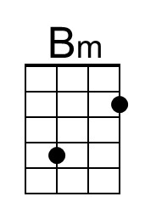 | 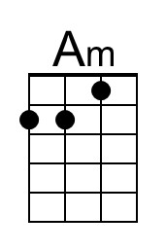 | 