**Here Comes Santa Claus (Gene Autry and O. Haldeman)**

C08

**C G7**

Here comes Santa Claus, here comes Santa Claus, right down Santa Claus Lane.



C

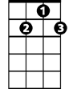

G7

**C C7**

Vixen and Blitzen and all his reindeer are pulling on the rein.

**F Em Dm G7 C**

Bells are ringing, children singing - All is merry and bright.

**F C A7 Dm G7 C**

Hang your stockings and say your prayers, 'Cause Santa Claus comes tonight.

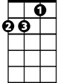

Dm

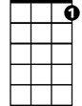

C7

**C G7**

Here comes Santa Claus, here comes Santa Claus, right down Santa Claus Lane.

**C C7**

He's got a bag that is filled with toys for the boys and girls again.

**F Em Dm G7 C**

Hear those sleigh bells jingle jangle, what a beautiful sight.

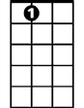

A7



Dm

**F C A7 Dm G7 C**

Jump in bed, cover up your head, 'Cause Santa Claus comes tonight!

**C G7**

Here comes Santa Claus, here comes Santa Claus, right down Santa Claus Lane.

**C C7**

He doesn’t care if you’re rich or poor, he loves you just the same

Em

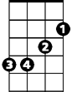

A7

**F Em Dm G7 C**

Santa Claus knows that we’re all God’s children, that makes everything right

**F C A7 Dm G7 C**

So fill your hearts with Christmas cheer, 'cause Santa Claus comes tonight

**C G7**

Here comes Santa Claus, here comes Santa Claus, right down Santa Claus Lane.

F



**C C7**

He'll come around when chimes ring out, it's Christmas time again

**F Em Dm G7 C**

Peace on earth will come to all, if we just follow the light

**F C A7 Dm G7 C**

So let's give thanks to the Lord above, 'cause Santa Claus comes tonight

**(Repeat First Verse)**

**BARITONE**

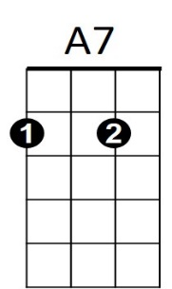

C



G7

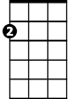

Em

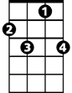

C7

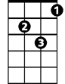

Dm



F