**Here Comes That Rainy Day Feeling Again Key C**

**(Roger Frederick Cook / Roger John Reginald Greenaway / Tony Macaulay)**

**INTRO: C Bb (x2) C**

F



C



Bb

**C Bb**

Here comes that rainy day feeling again.

**C Bb**

And soon my tears they will be falling like rain.

**F**

Em7

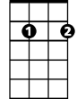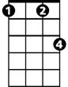

Fm

It always seems to be a Monday,

**Fm C Em7**

Left over memories of Sunday, always spent with you..

**F G C**

Before the clouds appeared, and took away my sunshi -ine.

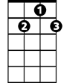

G7



G

**C Bb**

Here comes that rainy day feeling again.

**C Bb**

And I'll be dreaming of you Baby, in vain.

**F**

Your face is always on my mind girl,

**Fm C Em7**

**BARITONE**

I'm hoping soon you're gonna find, girl..your way back to me..

C

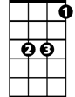

Bb

**F G C**

Cause if you say you'll stay, the rainy days will go away.

**C Bb**

**Fm C**

Misty morning eyes, I'm trying to disguise the way I feel..

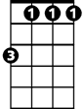

Fm



F

But I just can't hide it.

**Fm**

People seem to know, the loneliness must show..

**C G G7**

I'm thinking of my pride, but breaking up inside, girl, whoa -oh-oh.

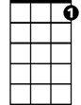

G7

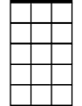

Em7



G

**(First Verse)**

**OUTRO:**

**C Bb**

Here comes that rainy day feeling again**..(x3)(Fade.)**

**Here Comes That Rainy Day Feeling Again Key G**

**(Roger Frederick Cook / Roger John Reginald Greenaway / Tony Macaulay)**

F



**BARITONE**

**INTRO: G F (x2) G**



C



G

**G F**

Here comes that rainy day feeling again.

**G F**

And soon my tears they will be falling like rain.

**C**

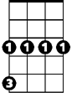

Cm

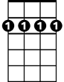

Bm7

It always seems to be a Monday,

**Cm G Bm7**

Left over memories of Sunday, always spent with you..

**C D G**

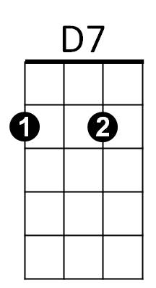Before the clouds appeared, and took away my sunshi -ine.

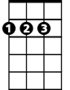

D

**G F**

Here comes that rainy day feeling again.

**G F**

And I'll be dreaming of you Baby, in vain.

**C**

Your face is always on my mind girl,

**Cm G Bm7**



F

I'm hoping soon you're gonna find, girl..your way back to me..



G

**C D G**

Cause if you say you'll stay, the rainy days will go away.

**G F**

**Cm G**

Misty morning eyes, I'm trying to disguise the way I feel..



Fm

C



But I just can't hide it.

**Cm**

People seem to know, the loneliness must show..

**G D D7**

I'm thinking of my pride, but breaking up inside, girl, whoa -oh-oh.

Bm7



D7



D

**(First Verse)**

**OUTRO:**

**G F**

Here comes that rainy day feeling again**..(x3)(Fade.)**