Here Comes The Rain Again (Annie Lennox / David Allan Stewart) (Em)

Em  Here comes the rain again  C  Falling on my head like a memory,  D Em  Falling on my head like a new emotion.  Em  I want to walk in the open wind.  C  I want to talk like lovers do.  D  I want to dive into your ocean.  Em  Is it raining with you?  Chorus:  C G  So baby, talk to me - Like lovers do.  C G  Walk with me - Like lovers do.  C G A D  Talk to me - Like lovers do.  Em  Here comes the rain again-  C  Raining in my head like a tragedy,  D Em  Tearing me apart like a new emotion.  Em  I want to breathe in the open wind.  C  I want to kiss like lovers do.  D  I want to dive into your ocean.  Em  Is it raining with you? Chorus  Bm C Em / Bm C D  Chorus |  |  |  |  | Em  Here comes the rain again  C  Falling on my head like a memory,  D Em  Falling on my head like a new emotion.  Here it goes again. - Here it goes again.  Em  I want to walk in the open wind.  C  I want to talk like lovers do.  D  I want to dive into your ocean.  Em  It is really with you.  Em  Here comes the rain again  C  Falling on my head like a memory,  D Em  Falling on my head like a new emotion.  Em  I want to walk in the open wind.  C  I want to talk like lovers do.  D  I want to dive into your ocean.  Em  Is it raining with you?  Em  Here comes the rain again-  C  Falling on my head like a memory,  D Em  Falling on my head like a new emotion. |  |  |  |  | 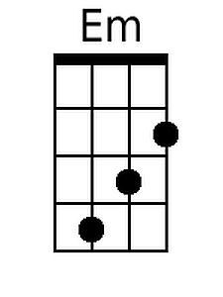
 |  |  |  |  |  |  |  |  |  | 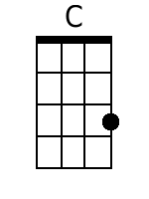
 |  |  |  |  |  |  |  |  |  | 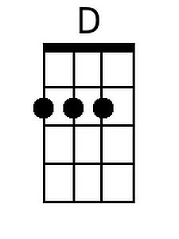
 |  |  |  |  |  |  |  |  |  | 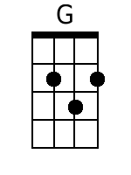
 |  |  |  |  |  |  |  |  |  | 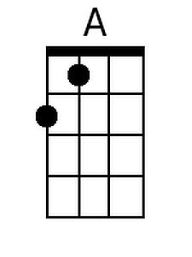
 |  |  |  |  |  |  |  |  |  | 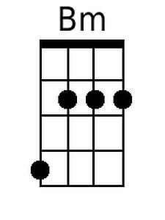
Bari
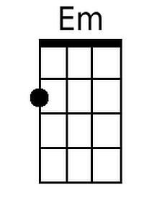 | 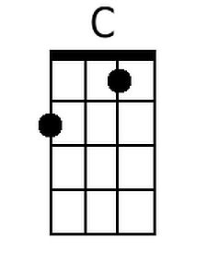 | 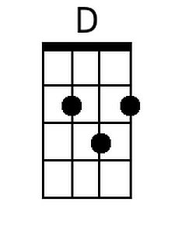 | 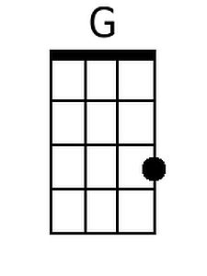 | 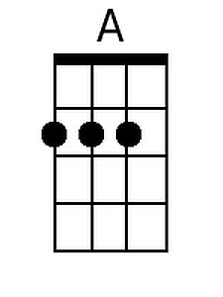 |  | 