**Here Comes the Sun (George Harrison) Key G**

**Intro: (melody for 2d and 3d lines of verse)**

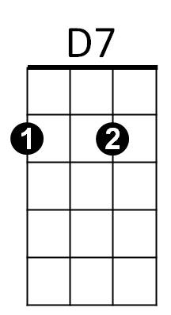**G**

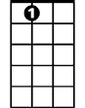

A7



Bb



C



G

F

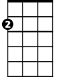

Am

Here comes the sun, (do-do-do-do)

**C A7 G C G Am G D7 / G D7**

Here comes the sun, and I say: "It's allright!"

**G C D7**

Little darling, it's been a long, cold, lonely winter

**G C D7**

Little darling, it feels like years since it's been here

**G**

Here comes the sun, (do-do-do-do)

**C A7 G C G Am G D7 / G D7**

Here comes the sun, and I say: "It's allright!"

**G C D7**

Little darling, the smile’s returning to their faces

**G C D7**

Little darling, it seems like years since it's been here

**G**

Here comes the sun, (do-do-do-do)

**C A7 G C G Am G D7 / G D7**

Here comes the sun, and I say: "It's allright!"

**Bb F C G D7**

**Bb F C G D7 Bb F C G D7**

**BARITONE**

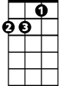

Am

C

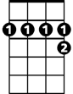

A7

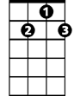

D7



F



G

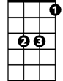

Bb

Sun, sun, sun, here it comes Sun, sun, sun, here it comes

**Bb F C G D7 Bb F C G D7**

Sun, sun, sun, here it comes Sun, sun, sun, here it comes

**Bb F C G D7**

Sun, sun, sun, here it comes

**G D7**

**G C D7**

Little darling, I feel that ice is slowly melting

**G C D7**

Little darling, it seems like years since it's been clear

**G**

Here comes the sun, (do-do-do-do)

**C A7 G C G Am G D7**

Here comes the sun, and I say: "It's allright!"

**G**

Here comes the sun, (do-do-do-do)

**C A7 G C G Am G D7**

Here comes the sun, and I say: "It's allright!"

**G C G Am G D7 / Bb F C G**

"It's allright!"

**Here Comes the Sun (George Harrison) Key D**

**Intro: (melody for 2d and 3d lines of verse)**

**D**

Here comes the sun,

**G E7 D G D Em7 D A7**

Here comes the sun, and I say: "It's allright!"

**D G A7**

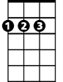

D



G

E7

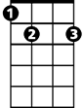

C

Em7

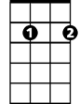

A7

F



Little darling, it's been a long, cold, lonely winter

**D G A7**

Little darling, it feels like years since it's been here

**D**

Here comes the sun, (do-do-do-do)

**G E7 D G D Em7 D A7**

Here comes the sun, and I say: "It's allright!"

**D A7**

**D G A7**

Little darling, the smile’s returning to their faces

**D G A7**

Little darling, it seems like years since it's been here

**D**

Here comes the sun, (do-do-do-do)

**G E7 D G D Em7 D A7**

Here comes the sun, and I say: "It's allright!"

**D A7 F C G D A7**

**BARITONE**

**F C G D A7 F C G D A7**



F

C



A7

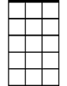

Em7



E7



G



D

Sun, sun, sun, here it comes Sun, sun, sun, here it comes

**F C G D A7 F C G D A7**

Sun, sun, sun, here it comes Sun, sun, sun, here it comes

**F C G D A7**

Sun, sun, sun, here it comes

**D A7**

**D G A7**

Little darling, I feel that ice is slowly melting

**D G A7**

Little darling, it seems like years since it's been here

**D**

Here comes the sun, (do-do-do-do)

**G E7 D G D Em7 D A7**

Here comes the sun, and I say: "It's allright!"

**D**

Here comes the sun, (do-do-do-do)

**G E7 D G D Em7 D A7**

Here comes the sun, and I say: "It's allright!"

**D G D Em7 D A7 / F C G D**

"It's allright!"