**Here, There and Everywhere (John Lennon / Paul McCartney)**

**C Em Eb Dm G7**

To lead a better life ~ I need my love to be here

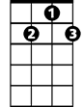

G7

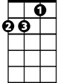

Dm

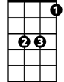

Eb

Em

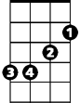

C

**C Dm Em F C Dm**

Here, making each day of the year

**Em7 F Bm7 E7**

Changing my life with a wave of her hand

**Bm7 E7 Am Dm G7**

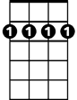

Bm7

Em7

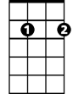

E7

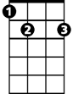

F



Nobody can deny that there's something there

**C Dm Em F C Dm**

There, running my hands through her hair

**Em7 F Bm7 E7**

Both of us thinking how good it can be

**Bm7 E7 Am Dm G7**

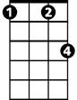

Fm

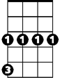

Cm

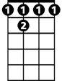

Bb7

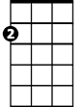

Am

Someone is speaking but she doesn't know he's there

**Bb7 Eb Cm**

I want her everywhere

**Fm G7 Cm**

And if she's beside me I know I need never care

**Fm G7**

But to love her is to need her

**BARITONE**

**C Dm Em F C Dm**



Em

Everywhere, knowing that love is to share

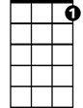

G7

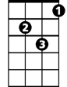

Dm

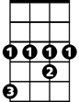

Eb

C



**Em7 F Bm7 E7**

Each one believing that love never dies

**Bm7 E7 Am Dm G7**

Watching her eyes and hoping I'm always there

**Bb7 Eb Cm**

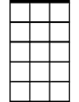

Em7

Bm7



F

I want her everywhere

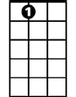

E7

**Fm G7 Cm**

And if she's beside me I know I need never care

**Fm G7**

But to love her is to need her

**C Dm Em F C Dm**

Everywhere, knowing that love is to share

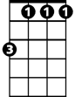

Fm



Cm

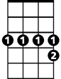

Bb7



Am

**Em7 F Bm7 E7**

Each one believing that love never dies

**Bm7 E7 Am Dm G7**

Watching her eyes and hoping I'm always there

**C Dm Em F**

I will be there, and everywhere

**C Dm Em F C**

Here, there and everywhere