**Hey Baby (Bruce Channel / Margaret Cobb) Key C**

**Intro: C Am F G 4x**



C

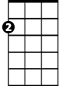

Am

F



G

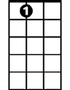

A7

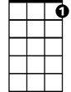

C7

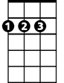

D

**Chorus:**

**C Am F G C Am F**

Hey, hey baby,

**G C Am F G C Am F G**

I wanna know if you'll be my girl.

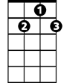

G7

**C Am F G C Am F**

Hey, hey baby,

**G C Am F G C F C C7**

I wanna know if you'll be my girl.

**F**

When I saw you walking down the street.

**C C7**

I said that's the kind of girl I'd like to meet.

**F**

She is so pretty, Lord, she's fine.

**G G7**

I'm gonna make her mine all mine.

**(Chorus)**

**A7 D**

When you turned and walked away, that's when I want to say

**G C**

Come on a baby, give me a whirl, I wanna know if you'll be my girl.

**(Chorus)**

**A7 D**

When you turned and walked away, that's when I want to say

**G C**

Come on a baby, give me a whirl, I wanna know if you'll be my girl.

**(Chorus) (fade out at end)**

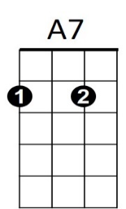

**BARITONE**

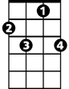

C7



D



G7



G



F

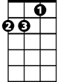

Am

C



**Hey Baby (Bruce Channel / Margaret Cobb) Key G**

**Intro: G Em C D 4x**

**Chorus:**

Em

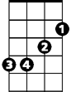

C



D



G

**G Em C D G Em C**

Hey, hey baby,

**D G Em C D G Em C D**

I wanna know if you'll be my girl.

**G Em C D G Em C**

E7

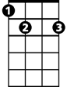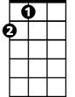

A



G7

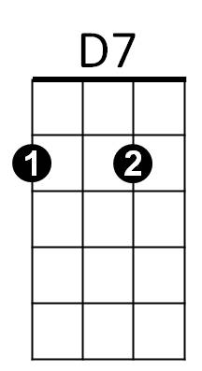Hey, hey baby,

**D G Em C D G C G G7**

I wanna know if you'll be my girl.

**C**

When I saw you walking down the street.

**G G7**

I said that's the kind of girl I'd like to meet.

**C**

She is so pretty, Lord, she's fine.

**D D7**

I'm gonna make her mine all mine.

**(Chorus)**

**E7 A**

When you turned and walked away, that's when I want to say

**D G**

Come on a baby, give me a whirl, I wanna know if you'll be my girl.

**(Chorus)**

**E7 A**

When you turned and walked away, that's when I want to say

**D G**

Come on a baby, give me a whirl, I wanna know if you'll be my girl.

**(Chorus) (fade out at end)**



D7



E7



G



Em

C



D



G7



A

**BARITONE**