Hi Jolly
Author: Randy Sparks, 1960, 1963.
Key of C Major -No Key Change.
Ukulele.

Note:
“Hi Jolly” is the Official town song of Quartzsite, Arizona.
Source: the blog at www.thenewchristyminstrels.com
Hi Jolly
Author: Randy Sparks, 1960, 1963. Note that BMI also gives credit to Bruce Davidson
Key of C Major – No Key Change. “Bright and Happy.” Ukulele.
Recorded by The New Christy Minstrels on their album Ramblin' (1963)

GCEA Uke  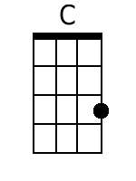  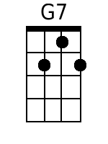  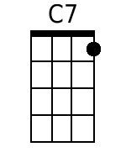  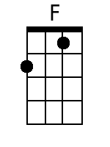 | Four Measure Introduction  Chorus  C G7  Hi Jolly, Hey Jolly,  C G7  Twenty miles to-day, by golly  C G7  Twenty more before the mornin' light  C7 F C G7  Hi Jolly, Hey I gotta be on my way;  C G7 C  I told my gal I'd be home Sunday night.  Verses  C  1. Hi Jolly was a camel driver, long time ago;  G7  Followed Mister Blain away out West.  C C7  'Didn't mind the burning' sand  F  In that God forsaken land;  G7 C - G7  But he didn't mind the purty girls the best. Chorus.  C  2. They've got purty girls in Albuquerque,  Least that's what I've heard;  G7  Purty girls in Tumcumcari, too.  C G7  Now honey, I ain't blind  F  But I don't pay 'em any mind;  G7 C – G7  You know I'm savin' all my lovin' just for you. Ha! Singin'  Chorus.  C  3. Old timers out in Arizona tell you that it's true;  G7  You can see Hi Jolly's ghost a-trav'lin' still.  C C7  When the desert moon is bright,  F  He comes ridin' through the night;  G C G7  Leadin' four and twenty camels 'cross the hill. And singin';  Chorus  C G7  Hi Jolly, Hey Jolly,  C G7  Twenty miles to-day, by golly;  C G7  Twenty more before the mornin' light  C7 F C G7  Hi Jolly, Hey I gotta be on my way;  C G7 C  I told my gal I'd be home Sunday night. A shoutin'  C G7  Hi Jolly, Hey Jolly,  C G7  Twenty miles to-day, by golly;  C G7  Twenty more before the mornin' light  C7 F C G7  Hi Jolly, Hey I gotta be on my way;  C G7 C  I told my gal I'd be home Sunday night.  C G7 C  Told my gal I'd be home Sunday night.  C G7 C – G7 – C [Spoken]  Told my gal I'd be home Sunday night. Yeah!
Bari Uke

