Hi Jolly
Author: Randy Sparks, 1960, 1963.
Key of G Major-No Key Change. Cut time.
Ukulele.

Note:
“Hi Jolly” is the Official town song of Quartzsite, Arizona.
Source: the blog at www.thenewchristyminstrels.com

Hi Jolly
Author: Randy Sparks, 1960, 1963. Note that BMI also gives credit to Bruce Davidson
Key of G Major – No Key Change. Cut time. “Bright and Happy.” Ukulele.
Recorded by The New Christy Minstrels on their album Ramblin' (1963)

GCEA Uke  G Major  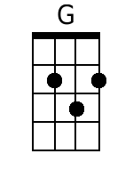  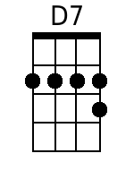  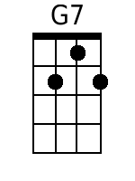  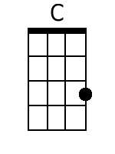 | Four Measure Introduction  Chorus  G D7  Hi Jolly, Hey Jolly,  G D7  Twenty miles to-day, by golly  G D7  Twenty more before the mornin' light  G7 C G D7  Hi Jolly, Hey I gotta be on my way;  G D7 G  I told my gal I'd be home Sunday night.  Verses  G  1. Hi Jolly was a camel driver, long time ago;  D7  Followed Mister Blain away out West.  G G7  'Didn't mind the burning' sand  C  In that God forsaken land;  D7 G - D7  But he didn't mind the purty girls the best. Chorus.  G  2. They've got purty girls in Albuquerque,  Least that's what I've heard;  D7  Purty girls in Tumcumcari, too.  G G7  Now honey, I ain't blind  C  But I don't pay 'em any mind;  D7 G – D7  You know I'm savin' all my lovin' just for you. Ha! Singin'  Chorus.  G  3. Old timers out in Arizona tell you that it's true;  D7  You can see Hi Jolly's ghost a-trav'lin' still.  G G7  When the desert moon is bright,  C  He comes ridin' through the night;  D G D7  Leadin' four and twenty camels 'cross the hill. And singin';  Chorus  G D7  Hi Jolly, Hey Jolly,  G D7  Twenty miles to-day, by golly;  G D7  Twenty more before the mornin' light.  G7 C G D7  Hi Jolly, Hey I gotta be on my way;  G D7 G  I told my gal I'd be home Sunday night. A shoutin'  G D7  Hi Jolly, Hey Jolly,  G D7  Twenty miles to-day, by golly;  G D7  Twenty more before the mornin' light.  G7 C G D7  Hi Jolly, Hey I gotta be on my way;  G D7 G  I told my gal I'd be home Sunday night.  G D7 G  Told my gal I'd be home Sunday night.  G D7 G – D7 – G [Spoken]  Told my gal I'd be home Sunday night. Yeah!
Bari Uke
G Major
