**High Hopes (Jimmy Van Heusen / Sammy Cahn)**

**C**

Next time you're found

**Gdim**

With your chin on the ground

**Dm**

there's a lot to be learned –

**G7 C Am Dm G7**

So look around

**C F**

Just what makes that little old ant

**G7 C**

Think he'll move that rubber tree plant

**Gdim Dm Cdim**

Anyone knows an ant, can't

**Dm G7 C**

Move a rubber tree plant

**Chorus:**

**G7 C7 F**

But he's got high hopes

**Cdim C**

He's got high hopes

**D7 G7**

He's got high apple pie in the sky hopes

**C**

So any time you're gettin' low

**C7 F CdIm**

'Stead of lettin' go, just remember that ant

**C Gdim Dm G7 C**

Oops, there goes another rubber tree plant

**C Gdim Dm G7 C**

Oops, there goes another rubber tree plant

F

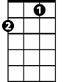

**C Gdim Dm G7 C**

Oops, there goes another rubber tree plant

**BARITONE**

**C Gdim**

When troubles call and your back's to the wall

**Dm**

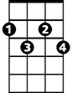

Gdim

C

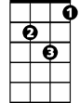

Dm

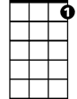

G7

There a lot to be learned –

**G7 C Am Dm G7**

That wall could fall

**C F**

Once there was a silly old ram

**G7 C**

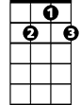

D7

Thought he'd punch a hole in a dam

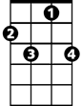

C7

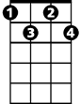

Cdim

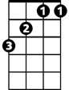

F

**Gdim Dm Cdim**

No one could make that ram, scram

**Dm G7 C**

He kept buttin' that dam

**(Chorus)**

**C**

So any time you're feelin' bad

**C7 F Cdim**

'Stead of feelin' sad, just remember that ram

**C Dm G7 C**

Oops, there goes a billion kilowatt dam

**C Dm G7 C**

Oops, there goes a billion kilowatt dam

**C Dm G7 C**

Oops, there goes a billion kilowatt dam

**(Chorus)**

**G7 C**

A problem’s just a toy balloon

**C7**

They'll be bursting soon,

**F Cdim**

They're just bound to go pop

**C Gdim Dm G7 C**

Oops, there goes a-nother problem kerplop

**C Gdim Dm G7 C**

Oops, there goes a-nother problem kerplop

**C Gdim Dm G7 C**

Oops, there goes a-nother problem kerplop

**G7 C**

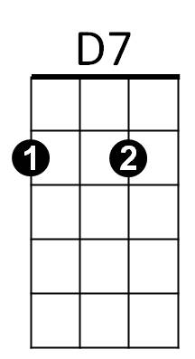Ker – plop!

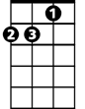

Am



Cdim

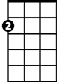

Am



C7



Dm

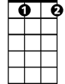

Gdim



G7

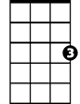

C