**Hoist the Colors High (Hans Zimmer)**

**Am**

The King and his men

**Dm Am**

Stole the Queen from her bed

**E7**

And bound her in her bones

The seas be ours and by the Powers

**Am**

Where we will, we’ll roam

**Am**

Yo ho, all hands

**E7**

Hoist the Colors high!

Heave ho, thieves and beggars

**Am**

Never shall we die

**Am Dm Am**

Now some have died and some are alive

**E7**

And others sail on the sea

With the keys to the cage and the Devil to pay

**Am**

We lay to Fiddler’s Green

**CHORUS:**

**Am**

Yo ho, haul together

**E7**

Hoist the Colors high!

Heave ho, thieves and beggars

**Am**

Never shall we die

**Am**

The bell has been raised

**Dm Am**

From its watery grave

**E7**

Hear its sep-ulch-ral tone

A call to all, pay heed to the squall

**Am**

And turn your sails to home

**(CHORUS 2X)**

**(First verse)**

**E7 Am**

Where we will, we’ll roam

E7

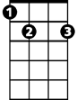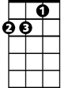

Dm

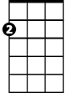

Am

**BARITONE**

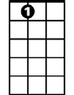

E7



Am

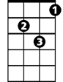

Dm