**Hooked On A Feeling (Mark James) (Blue Swede version) Key C**

**Intro:** Ooogachaka ooga ooga **(4x)**



C

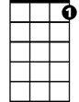

C7

**C C7 F**

I can't stop this feeling deep inside of me

**C G7**

But girl you just don't realize what you do to me

**BARITONE**

**C C7**

When you hold me in your arms so tight

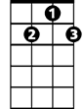

G7

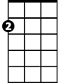

Am

**Am C7**

You let me know every thing's alright

**Chorus:**

**F G7 C**

Ah, I'm hooked on a feeling

**C7 F**

High on believing

**G7 C G7**

That you're in love with m—e

**C C7 F**

Your lips are sweet as candy the taste stays on my mind

**C G7**

Girl you keep me thirsty for another cup of wine

**C C7 F**

I got it bad for you girl but I don't need a cure

**C G7**

I'll just stay a victim if I can for sure

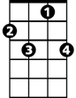

C7



F

CF



**C C7**

All the good love when we're all alone

**Am C7**

Keep it up girl, yeah, you turn me on

**(Chorus)**



G7

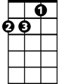

Am

**C G7 C7 F G7**

**C C7**

All the good love when we're all alone

**Am C7**

Keep it up girl, yeah, you turn me on

**(Chorus) 2x**

**Hooked On A Feeling (Mark James) (Blue Swede version) Key G**

**Intro:** Ooogachaka ooga ooga **(4x)**



G7



G



C

**G G7 C**

I can't stop this feeling deep inside of me

**G D7**

But girl you just don't realize what you do to me

**G G7**

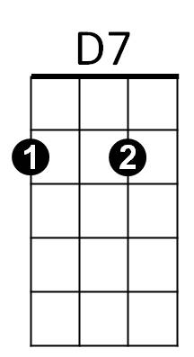When you hold me in your arms so tight

Em

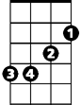

**Em G7**

You let me know every thing's alright

**Chorus:**

**C D7 G**

Ah, I'm hooked on a feeling

**G7 C**

High on believing

**D7 G D7**

That you're in love with m—e

**G G7 C**

Your lips are sweet as candy the taste stays on my mind

**G D7**

Girl you keep me thirsty for another cup of wine

**G G7 C**

I got it bad for you girl but I don't need a cure

**BARITONE**

**G D7**



G7



G

C



D7



Em

I'll just stay a victim if I can for sure

**G G7**

All the good love when we're all alone

**Em G7**

Keep it up girl, yeah, you turn me on

**(Chorus)**

**G D7 G7 C D7**

**G G7**

All the good love when we're all alone

**Em G7**

Keep it up girl, yeah, you turn me on

**(Chorus) 2x**