Hotel California (Felder, Henley & Frey, 1976) (Em)

Intro: Melody for verse 2x  Em B7  On a dark desert highway, cool wind in my hair  D A  Warm smell of colitas rising up through the air  C G  Up ahead in the distance, I saw a shimmering light  Am  My head grew heavy and my sight grew dim,  B7  I had to stop for the night  Em B7  There she stood in the doorway; I heard the mission bell  D  And I was thinking to myself  A  This could be heaven or this could be hell  C G  Then she lit up a candle, and she showed me the way  Am B7  There were voices down the corridor, I thought I heard them say...  C G  Welcome to the Hotel California.  B7 Em  Such a lovely place, such a lovely face  C G  Plenty of room at the Hotel California  Am B7  Any time of year, you can find it here  Em B7  Her mind is Tiffany-twisted, she got the Mercedes bends  D A  She got a lot of pretty pretty boys she calls friends  C G  How they danced in the courtyard, sweet summer sweat  Am B7  Some dance to remember, some dance to forget | 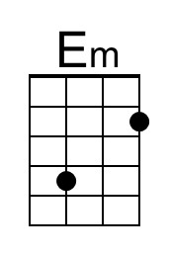 | 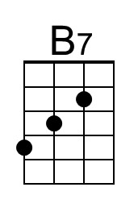
 | 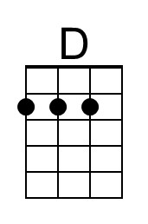 | 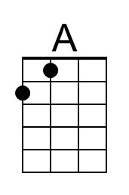
 | 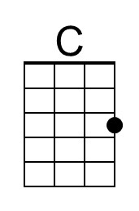 | 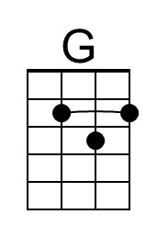
 | 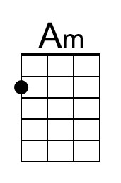
 | 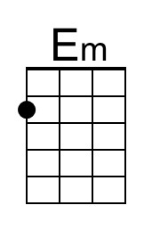 | 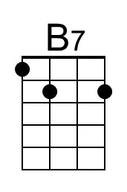
 | 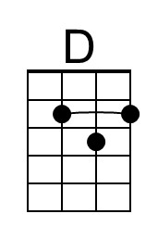 | 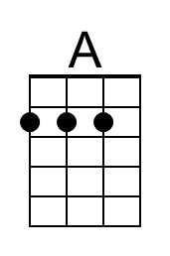
 | 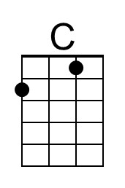 | 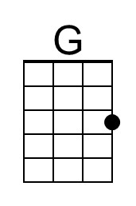
 | 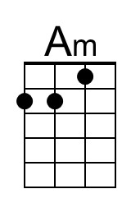

Hotel California (Em) – Page 2

Em B7
So I called up the captain; Please bring me my wine (he said)
D A
We haven't had that spirit here since 1969
C G
And still those voices are calling from far away
Am B7
Wake you up in the middle of the night just to hear them say...

C G
Welcome to the Hotel California.
B7 Em
Such a lovely place, such a lovely face
C G
They're livin' it up at the Hotel California
Am B7
What a nice surprise, bring your alibis

Em B7
Mirrors on the ceiling; the pink champagne on ice (and she said)
D A
We are all just prisoners here, of our own device
C G
And in the master's chambers, they gathered for the feast
Am B7
They stab it with their steely knives but they just can't kill the beast

Em B7
Last thing I remember, I was running for the door
D A
I had to find the passage back to the place I was before
C G
"Relax" said the night man; we are programmed to receive
Am B7
You can check out any time you like - but you can never leave...

Instrumental verse 2x

