**Hotel California (Don Felder / Glenn Frey)**

**BARITONE**

**Intro: Verse melody**

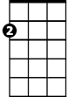

Am

E7

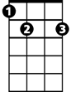

**Am E7**

On a dark desert highway, cool wi nd in my hair

**G D7**

Warm smell of colitas rising up through the air

**F C**

Up ahead in the distance, I saw a shimmering light

**Dm E7**

My head grew heavy and my sight grew dim; I had to stop for the night.

**Am E7**

There she stood in the doorway; I heard the mission bell

**G D7**

And I was thinking to myself, “This could be Heaven or this could be Hell”

**F C**

Then she lit up a candle and she showed me the way

**Dm E7**

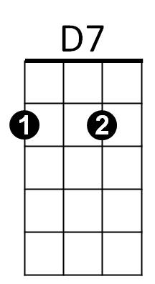There were voices down the corridor, I thought I heard them say...



G

**F C**

Welcome to the Hotel California...

**E7 Am G C**

Such a lovely place, such a lovely face...

**F C**

Plenty of room at the Hotel California...

**Dm E7**

F



Any time of year, you can find it here...

**Am E7**

Her mind is Tiffany-twisted, she got the Mercedes Bends

**G D7**

She got a lot of pretty, pretty boys, that she calls friends

**F C**



C

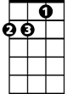

Dm

How they dance in the courtyard, sweet summer sweat

**Dm E7**

Some dance to remember, some dance to forget

**Am E7**



Am

So I called up the Captain, "Please bring me my wine"

**G D7**

He said, "We haven't had that spirit here since nineteen sixty nine"

**F C**

And still those voices are calling from far away,

**Dm E7**

Wake you up in the middle of the night just to hear them say...

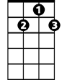

D7

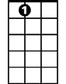

E7



G

**F C**

Welcome to the Hotel California...

**E7 Am G C**

Such a lovely place, such a lovely face...

**F C**

They’re livin' it up at the Hotel California...

**Dm E7**



F

What a nice surprise, bring your alibis...

**Am E7**

Mirrors on the ceiling, the pink champagne on ice

**G D7**

And she said "We are all just prisoners here, of our own device"

**F C**

C



And in the master's chambers, they gathered for the feast

**Dm E7**

They stab it with their steely knives, but they just can't kill the beast

**Am E7**

Last thing I remember, I was running for the door

**G D7**

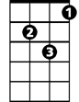

Dm

I had to find the passage back to place I was before

**F C**

"Relax" said the night man, "We are programmed to receive.

**Dm E7**

You can check out any time you like, but you can never leave".

**Repeat verse melody to fade**