**Hotel California**

**Intro: Melody for verse 2x**



G

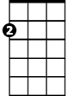

Am

E7

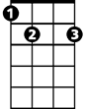

**Am E7**

On a dark desert highway, cool wind in my hair

**G D**

Warm smell of colitas rising up through the air

**F C**



C

F

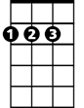

D

Up ahead in the distance, I saw a shimmering light

**Dm**

My head grew heavy and my sight grew dim,

**E7**

I had to stop for th e night

**Am E7**

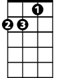

Dm

There she stood in the doorway; I heard the mission bell

**G**

And I was thinking to myself

**D**

This could be heaven or this could be hell

**F C**

Then she lit up a candle, and she showed me the way

**Dm E7**

There were voices down the corridor, I thought I heard them say...

**BARITONE**

**F C**

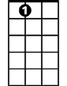

E7



Am



G

Welcome to the Hotel California.

**E7 Am**

Such a lovely place, such a lovely face

**F C**

Plenty of room at the Hotel California

**Dm E7**



D



F

C



Any time of year, you can find it here

**Am E7**

Her mind is Tiffany-twisted, she got the Mercedes bends

**G D**

She got a lot of pretty pretty boys she calls friends

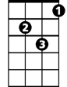

Dm

**F C**

How they danced in the courtyard, sweet summer sweat

**Dm E7**

Some dance to remember, some dance to forget

**Am E7**

So I called up the captain; Please bring me my wine (he said)

**G D**

We haven't had that spirit here since 1969

**F C**

And still those voices are calling from far away

**Dm E7**

Wake you up in the middle of the night just to hear them say...

**F C**

Welcome to the Hotel California.

**E7 Am**

Such a lovely place, such a lovely face

**F C**

They're livin' it up at the Hotel California

**Dm E7**

What a nice surprise, bring your alibis

**Am E7**

Mirrors on the ceiling; the pink champagne on ice (and she said)

**G D**

We are all just prisoners here, of our own device

**F C**

And in the master's chambers, they gathered for the feast

**Dm E7**

They stab it with their steely knives but they just can't kill the beast

**Am E7**

Last thing I remember, I was running for the door

**G D**

I had to find the passage back to the place I was before

**F C**

"Relax" said the night man; we are programmed to receive

**Dm E7**

You can check out any time you like - but you can never leave...

**Instrumental verse 2x**