House At Pooh Corner by Kenny Loggins (ca. 1966)

Keys of C & G in a two-page format
Lyrics, chords, and chord diagrams for Ukulele

This work is the author’s interpretation. Copyright belongs to the creator and performers.
Please respect the copyright laws in your country.

Note that the original has a change of key near the end of the second chorus. That is not reproduced here as the number of chords (which has been simplified in this version) would increase to 23!

Written by Kenny Loggins in his senior year of high school, it was first recorded by the Nitty Gritty Dirt Band in 1970 on their album “Uncle Charlie & His Dog Teddy,” and then by Loggins and Jim Messina in 1971 on their album “Sittin’In.“ It is told from the perspective of both Winnie-the-Pooh and Christopher Robin, and serves as an allegory for loss of innocence and nostalgia for childhood. He later explained that he was about to graduate from high school and was thinking about the final chapter from the 1928 book by A.A. Milne, "The House at Pooh Corner."
It was the first book I ever read. The last chapter is where Christopher Robin is leaving the Hundred Acre Wood, and he's telling everybody goodbye. I felt like that was akin to what I was going through in high school. Some part of me knew that I was leaving my childhood behind. I didn't really think it through like that. It just sort of came through.
The first recording was initially blocked by the Walt Disney Corporation, who held the copyright to Winnie The Pooh, but this objection was later dropped after a girl that Kenny was dating mentioned this to her father, who was – unknown to Loggins – the CEO of the Disney Corporation. It has since become one of Loggins' most popular and beloved compositions, and it remains a staple of his live performances.
In 1994, Loggins re-recorded the song (with an additional verse from the perspective of a father) under the title "Return to Pooh Corner", a duet with Amy Grant, featuring backing vocals from Grant's then-husband, Gary Chapman. It appears on Loggins’ album of the same name.
Sources:
- House On Pooh Corner, Wikipedia.
- Story Behind The Song "House At Pooh Corner" by Dave Paulson, The Tennessean, Sept. 7, 2014.

YouTube Links:
- House On Pooh Corner by Loggins and Messina from the album "Sittin' In" (1971)
- House On Pooh Corner by Loggins and Messina, live from "Sittin' In Again" at the Santa Barbara Bowl (2012)
- House On Pooh Corner by Nitty Gritty Dirt Band from the LP "Uncle Charlie & His Dog Teddy" (1970). This was one of four Kenny Loggins songs performed on this LP.
- House On Pooh Corner Detailed Tutorial by Rainy Day Guitar (49:36)
- Return To Pooh Corner by Kenny Loggins and Amy Grant (1994)
- Return To Pooh Corner by Kenny Loggins, live at Fallsview (2018)

House at Pooh Corner (Kenny Loggins) (C)

Intro | Am F C Dm | Dm Gsus4 | [2x]  C Dm Em Am  Christopher Robin and I walked a-long,  Dm G7sus4 | C G F Em |  Under branches lit up by the moon  C Dm Em Am  Posing our questions to Owl and Ee-yore,  Dm G7sus4 C  As our days dis-ap-peared all too soon  Am Em  But I've wandered much further to-day than I should  Fmaj7 D7 G  And I can't seem to find my way back to the wood.  Chorus  C Em Dm G7sus4  So, help me if you can, I've got to get  C Em Dm G7sus4 – G7  Back to the house at Pooh Corner by one  C Em Dm G – G7  You'd be sur-prised, there's so much to be done  Em C  Count all the bees in the hive,  Em Am  Chase all the clouds from the sky  F Em Am  Back to the days of Christopher Robin  Bbmaj7 | G7 |  and Pooh.  C Dm Em Am  Winnie the Pooh doesn't know what to do,  Dm G7sus4 | C G F Em |  Got a honey jar stuck on his nose  C Dm Em Am  He came to me asking help and ad-vice,  Dm G7sus4 C  And from here no one knows where he goes  Am Em  So, I sent him to ask of the Owl, if he's there  Fmaj7 D7 G  How to loosen a jar from the nose of a bear. Chorus | 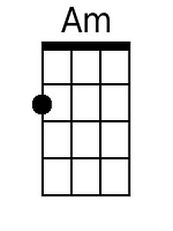 |  | 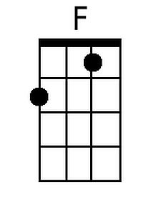 |  | 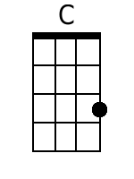
 | 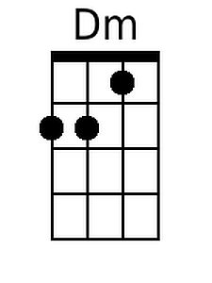 | 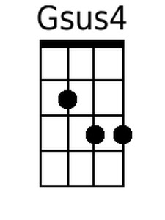 |  |  |  | 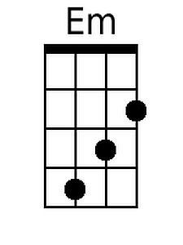
 | 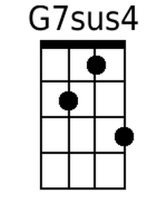 | 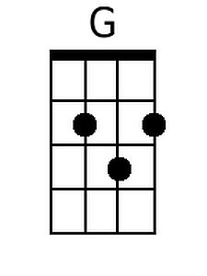 |  |  |  | 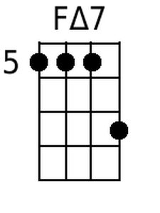
 | 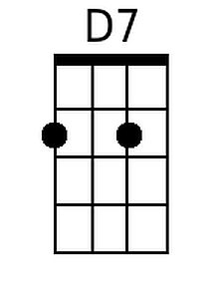 | 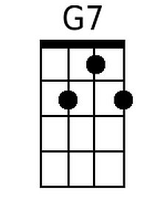 |  |  |  | 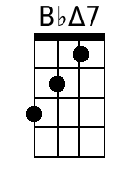
 | Bari
 | 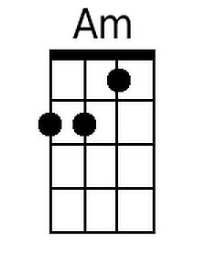 | 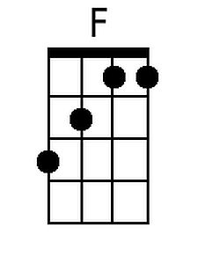 |  |  |  | 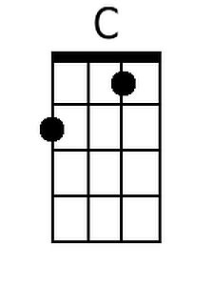
 | 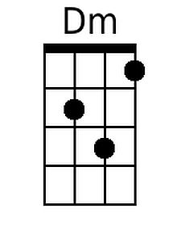 | 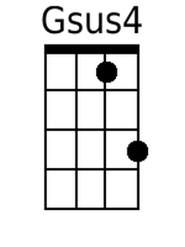 |  |  |  | 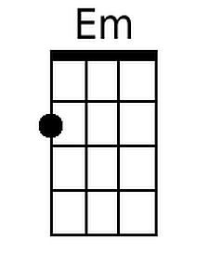
 | 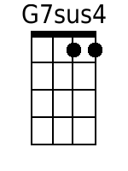 | 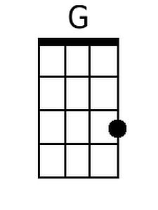 |  |  |  | 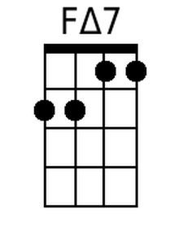
 | 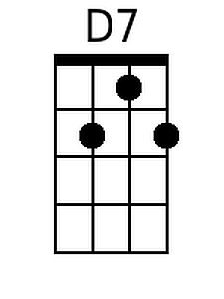 |  |  | 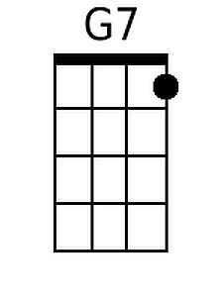 |  | 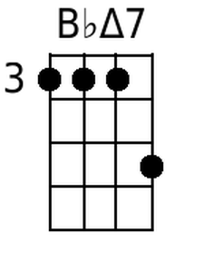

House At Pooh Corner (C) – Page 2

| C Dm | Em Am | F G7sus4 | C C G F | [2x]

C Dm Em Am Dm G7sus4 | C G F Em | [2x]
La la la la la la la la la, La la la la la la

C Em Dm G7sus4
So, help me if you can, I've got to get
C Em Dm G7sus4 – G7
Back to the house at Pooh Corner by one
C Em Dm G – G7
You'd be sur-prised, there's so much to be done
Em C
Count all the bees in the hive,
Em Am
Chase all the clouds from the sky.
F Em Am
Back to the days of Christopher Robin
F Em Am
Back to the ways of Christopher Robin
F G Am | F G | Am |
Back to the ways of Pooh.
| F G | Am F C Dm | G C |
Oo _ _ _ _ _ _ _ _ _ _ _ _ _
| C Em Dm G7sus4 | C Em Dm G7sus4 | C (Hold)
House at Pooh Corner (Kenny Loggins) (G)

Intro | Em C G Am | Am Dsus4 | [2x]  G Am Bm Em  Christopher Robin and I walked a-long,  Am D7sus4 | G D C Bm |  Under branches lit up by the moon.  G Am Bm Em  Posing our questions to Owl and Ee-yore,  Am D7sus4 G  As our days dis-ap-peared all too soon.  Em Bm  But I've wandered much further to-day than I should  Cmaj7 A7 D  And I can't seem to find my way back to the wood.  Chorus  G Bm Am D7sus4  So, help me if you can, I've got to get  G Bm Am D7sus4 – D7  Back to the house at Pooh Corner by one  G Bm Am D – D7  You'd be sur-prised, there's so much to be done  Bm G  Count all the bees in the hive,  Bm Em  Chase all the clouds from the sky  C Bm Em Fmaj7 | D7 |  Back to the days of Christopher Robin and Pooh.  G Am Bm Em  Winnie the Pooh doesn't know what to do,  Am D7sus4 | G D C Bm |  Got a honey jar stuck on his nose.  G Am Bm Em  He came to me asking help and ad-vice,  Am D7sus4 G  And from here no one knows where he goes.  Em Bm  So, I sent him to ask of the Owl, if he's there,  Cmaj7 A7 D  How to loosen a jar from the nose of a bear. Chorus |  |  | 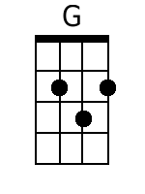
 |  | 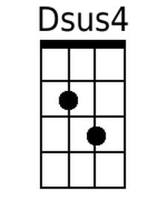 | 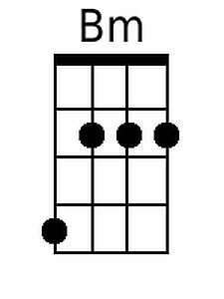
 | 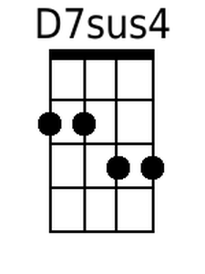 | 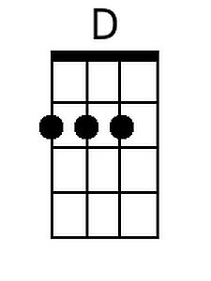 | 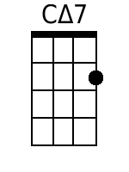
 | 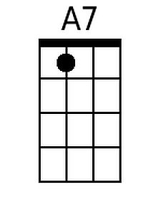
 | Bari
 |  | 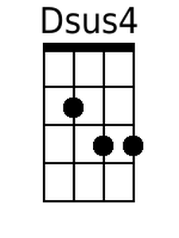 | 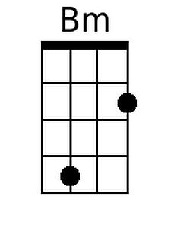
 | 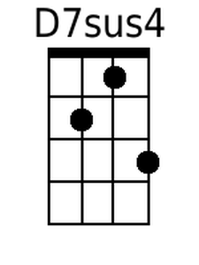 | 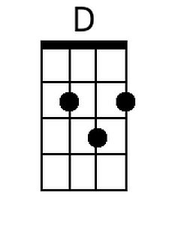 | 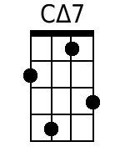
 | 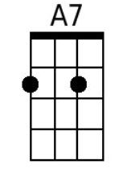
House At Pooh Corner (G) - Page 2

| G Am | Bm Em | C D7sus | G D C Bm | [2x]

G Am Bm Em Am D7sus | G G D C | [2x]
La la la la la la la la la, La la la la la la.

G Bm Am D7sus4
So, help me if you can, I've got to get
G Bm Am D7sus 4 – D7
Back to the house at Pooh Corner by one.
G Bm Am D – D7
You'd be sur-prised, there's so much to be done.
Bm G
Count all the bees in the hive,
Bm Em
Chase all the clouds from the sky.
C Bm Em
Back to the days of Christopher Robin,
C Bm Em
Back to the ways of Christopher Robin,
C D Em | C D | Em |
Back to the ways of Pooh.
| C D | Em C G Am | D G |
Oo _ _ _ _ _ _ _ _ _ _ _ _ _
| G Bm Am D7sus4 | G Bm Am D7sus4 | G (Hold)

