House at Pooh Corner (Kenny Loggins, ca. 1966) (C)

Intro | Am F C Dm | Dm Gsus4 | [2x]  C Dm Em Am  Christopher Robin and I walked a-long,  Dm G7sus4 | C G F Em |  Under branches lit up by the moon  C Dm Em Am  Posing our questions to Owl and Ee-yore,  Dm G7sus4 C  As our days dis-ap-peared all too soon  Am Em  But I've wandered much further to-day than I should  Fmaj7 D7 G  And I can't seem to find my way back to the wood.  Chorus  C Em Dm G7sus4  So, help me if you can, I've got to get  C Em Dm G7sus4 – G7  Back to the house at Pooh Corner by one  C Em Dm G – G7  You'd be sur-prised, there's so much to be done  Em C  Count all the bees in the hive,  Em Am  Chase all the clouds from the sky  F Em Am  Back to the days of Christopher Robin  Bbmaj7 | G7 |  and Pooh.  C Dm Em Am  Winnie the Pooh doesn't know what to do,  Dm G7sus4 | C G F Em |  Got a honey jar stuck on his nose  C Dm Em Am  He came to me asking help and ad-vice,  Dm G7sus4 C  And from here no one knows where he goes  Am Em  So, I sent him to ask of the Owl, if he's there  Fmaj7 D7 G  How to loosen a jar from the nose of a bear. Chorus | 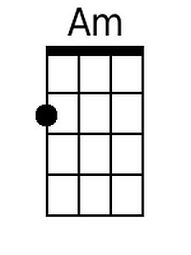 | 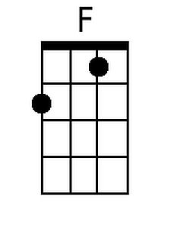 |  | 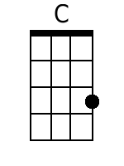
 | 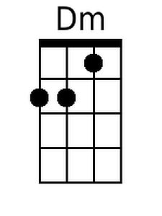 | 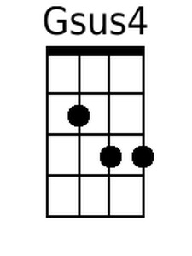 |  |  | 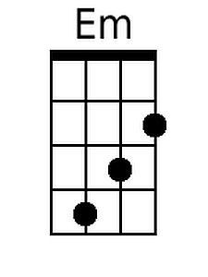
 | 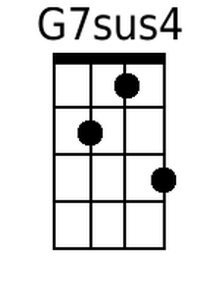 | 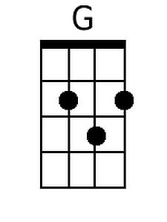 |  |  | 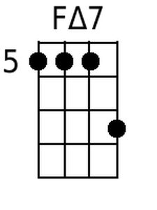
 | 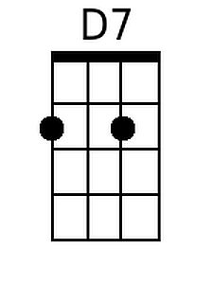 | 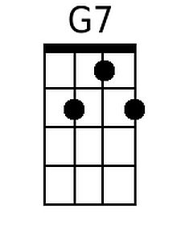 |  |  | 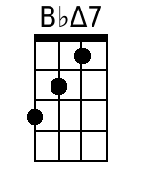
 | Bari
 | 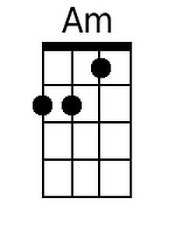 | 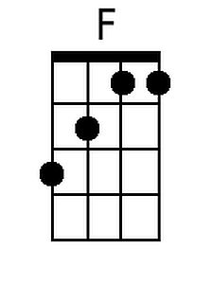 |  |  | 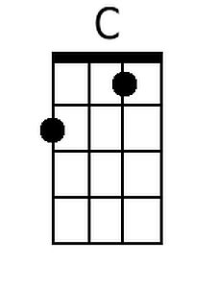
 | 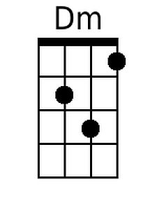 | 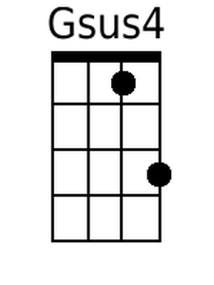 |  |  | 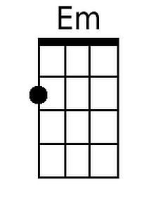
 | 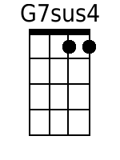 | 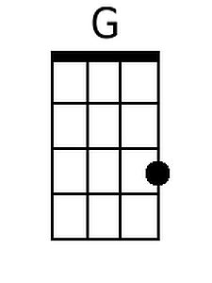 |  |  | 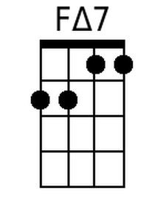
 | 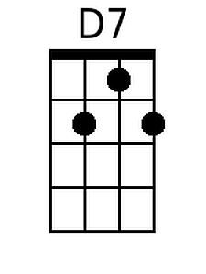 |  | 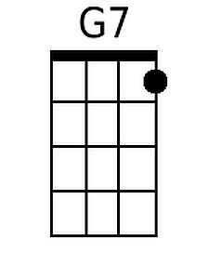 |  | 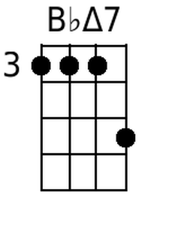

House At Pooh Corner (C) – Page 2

| C Dm | Em Am | F G7sus4 | C C G F | [2x]

C Dm Em Am Dm G7sus4 | C G F Em | [2x]
La la la la la la la la la, La la la la la la

C Em Dm G7sus4
So, help me if you can, I've got to get
C Em Dm G7sus4 – G7
Back to the house at Pooh Corner by one
C Em Dm G – G7
You'd be sur-prised, there's so much to be done
Em C
Count all the bees in the hive,
Em Am
Chase all the clouds from the sky.
F Em Am
Back to the days of Christopher Robin
F Em Am
Back to the ways of Christopher Robin
F G Am | F G | Am |
Back to the ways of Pooh.
| F G | Am F C Dm | G C |
Oo _ _ _ _ _ _ _ _ _ _ _ _ _
| C Em Dm G7sus4 | C Em Dm G7sus4 | C (Hold)
House at Pooh Corner (Kenny Loggins, ca. 1966) (G)

Intro | Em C G Am | Am Dsus4 | [2x]  G Am Bm Em  Christopher Robin and I walked a-long,  Am D7sus4 | G D C Bm |  Under branches lit up by the moon.  G Am Bm Em  Posing our questions to Owl and Ee-yore,  Am D7sus4 G  As our days dis-ap-peared all too soon.  Em Bm  But I've wandered much further to-day than I should  Cmaj7 A7 D  And I can't seem to find my way back to the wood.  Chorus  G Bm Am D7sus4  So, help me if you can, I've got to get  G Bm Am D7sus4 – D7  Back to the house at Pooh Corner by one  G Bm Am D – D7  You'd be sur-prised, there's so much to be done  Bm G  Count all the bees in the hive,  Bm Em  Chase all the clouds from the sky  C Bm Em Fmaj7 | D7 |  Back to the days of Christopher Robin and Pooh.  G Am Bm Em  Winnie the Pooh doesn't know what to do,  Am D7sus4 | G D C Bm |  Got a honey jar stuck on his nose.  G Am Bm Em  He came to me asking help and ad-vice,  Am D7sus4 G  And from here no one knows where he goes.  Em Bm  So, I sent him to ask of the Owl, if he's there,  Cmaj7 A7 D  How to loosen a jar from the nose of a bear. Chorus |  |  | 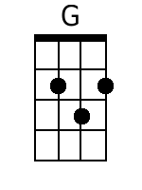
 |  | 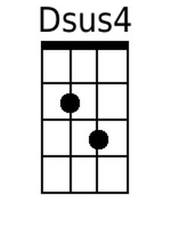 | 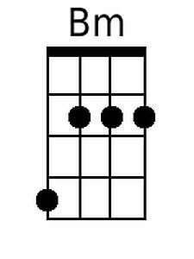
 | 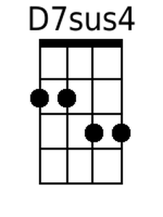 | 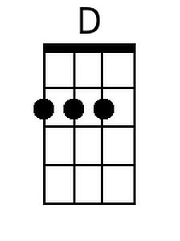 | 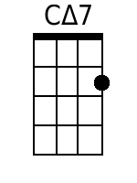
 | 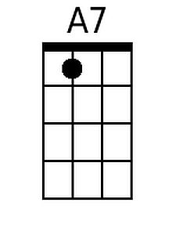
 | Bari
 |  | 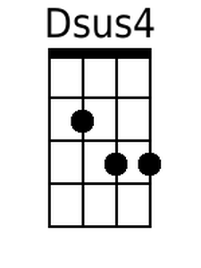 | 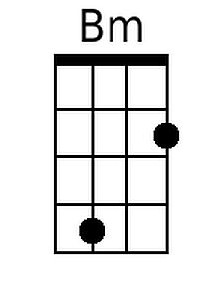
 | 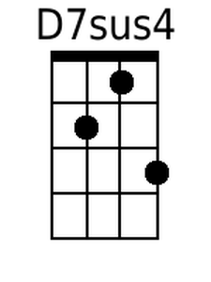 | 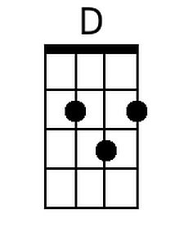 | 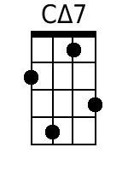
 | 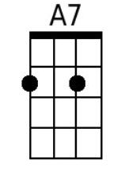
House At Pooh Corner (G) - Page 2

| G Am | Bm Em | C D7sus | G D C Bm | [2x]

G Am Bm Em Am D7sus | G G D C | [2x]
La la la la la la la la la, La la la la la la.

G Bm Am D7sus4
So, help me if you can, I've got to get
G Bm Am D7sus 4 – D7
Back to the house at Pooh Corner by one.
G Bm Am D – D7
You'd be sur-prised, there's so much to be done.
Bm G
Count all the bees in the hive,
Bm Em
Chase all the clouds from the sky.
C Bm Em
Back to the days of Christopher Robin,
C Bm Em
Back to the ways of Christopher Robin,
C D Em | C D | Em |
Back to the ways of Pooh.
| C D | Em C G Am | D G |
Oo _ _ _ _ _ _ _ _ _ _ _ _ _
| G Bm Am D7sus4 | G Bm Am D7sus4 | G (Hold)

