Possible Descending Runs With Barre Chords

Key of C
Soprano/Concert/Tenor

 | The descending run is this sequence:
C | C | G | F | Em | C
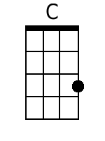 |  | 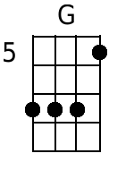 | 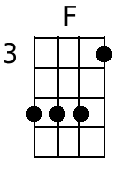 | 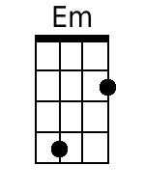 |  | Not Good! The dreaded “E” Form
 |  | 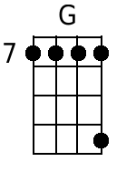 | 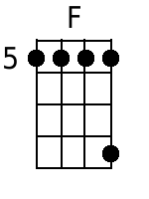 | 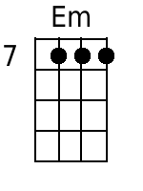 | 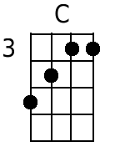

Baritone

 | The descending run is this sequence:
C | C | G | F | Em | C
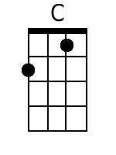 |  | 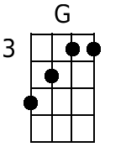 | 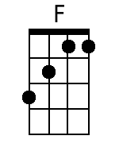 | 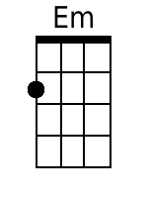

Key of G
Soprano/Concert/Tenor

 | The descending run is this sequence:
G | G | D | C | Bm | G
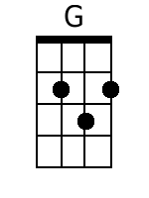 |  | 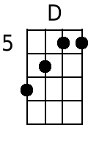 |  | 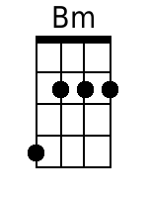

Baritone

 | The descending run is this sequence:
G | G | D | C | Bm | G
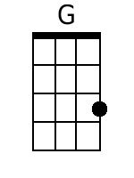 |  | 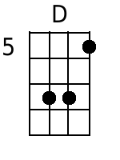 | 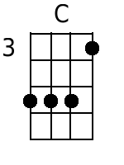 | 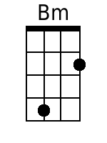 |  | Not Good! The dreaded “Bb” Form
 |  | 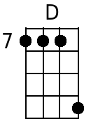 | 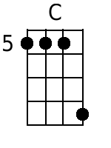 | 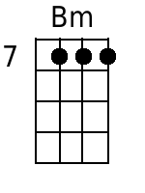

In the sheet music that I purchased, the original run was C C G F, but that didn’t match the first recording by Loggins and Messina, which clearly has a four note descent (i.e., G F Em C). It it’s easier, possibly an E7 instead of an Em?

Other Possible Runs?

Soprano/Concert/Tenor

 | The descending “run” is this sequence:
G | G | D6 | C6 | Bm | G
 |  | 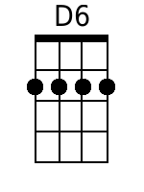 | 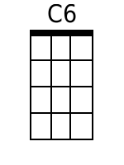
G | G | Dm7 | Cm7 | Bm7 | G
 |  | 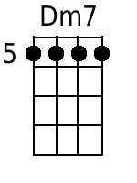 | 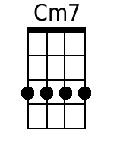 | 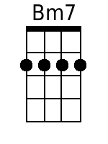

Baritone

 | The descending run is this sequence:
G | G | D6 | C6 | B6 | G
 |  | 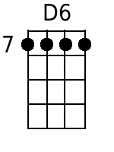 | 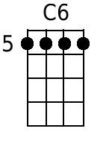 | 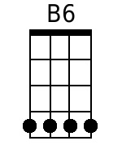
G | G | Dm7 | Cm7 | Bm7 | G
 |  | 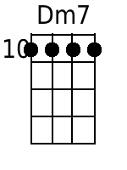 | 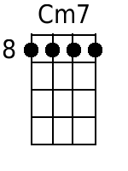 | 