House of the Rising Sun (Traditional, adapted by Eric Burdon) (Am)
House of the Rising Sun by The Animals – 6/8 Time

Intro: Am C | D F | Am E7 | Am E7  Am C D F Am C E7  There is a house in New Orleans, They call the Risin' Sun  Am C D F Am E7 Am - E7  And it's been the ruin of many a poor boy. And God, I know I'm one. Repeat  Intro  Am C D - F Am C E7  My mother was a tailor. She sewed my new blue jeans.  Am C D F Am E7 Am - E7  My father was a gamblin' man, Down in New Or-leans. Repeat Intro  Am C D F Am C E7  Now, the only thing a gambler needs, is a suitcase and a trunk  Am C D F Am E7 Am - E7  And the only time that he's satis-fied, is when he's on a drunk. Repeat Intro  Instrumental Verse. Repeat Intro  Am C D - F Am C E7  Oh, Mother, tell your children Not to do what I have done.  Am C D F Am E7 Am - E7  Spend your lives in sin and miser-y in the House of the Risin' Sun. Repeat  Intro  Am C D - F Am C E7  Well, I've got one foot on the platform. The other foot on the train.  Am C D - F Am E7 Am - E7  I'm goin' back to New Orleans, To wear that ball and chain. Repeat Intro  Am C D - F Am C E7  There is a house in New Orleans They call the Risin' Sun  Am C D F Am E7 Am - E7  And it's been the ruin of many a poor boy. And God, I know I'm one.  Am C | D F | Am E7 | Am D | Am D | Am D | Am |  |  |  |  |  |  | 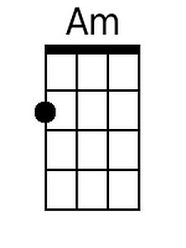
 |  |  |  |  |  |  | 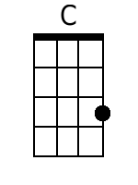
 |  |  |  |  |  |  | 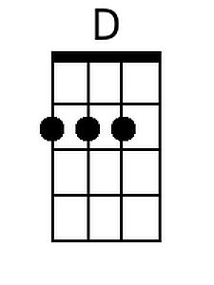
 |  |  |  |  |  |  | 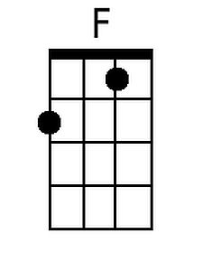
 |  |  |  |  |  |  | 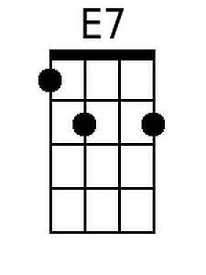
Strum:  1 2& 3&  D DU DU |  | Bari | 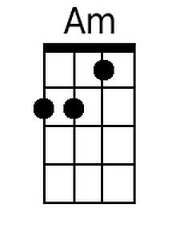 | 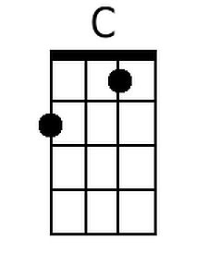 | 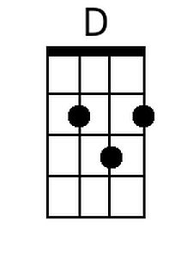 | 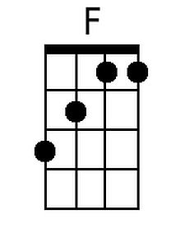 | 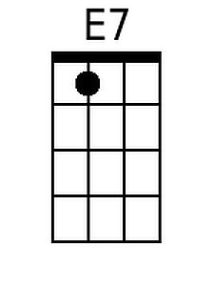

Note: Repetition of the Intro after every verse is optional. Baritones can re-create the Animals opening by doing an arpeggio of each chord in the Introduction (especially if amplified).
House of the Rising Sun (Traditional, adapted by Eric Burdon) (Em)
House of the Rising Sun by The Animals – 6/8 Time

Intro: Em G | A C | Em B7 | Em B7  Em G A C Em G B7  There is a house in New Or-leans, They call the Risin' Sun  Em G A C Em B7 Em - B7  And it's been the ruin of many a poor boy. And God, I know I'm one. Repeat  Intro  Em G A - C Em G B7  My mother was a tailor. She sewed my new blue jeans.  Em G A C Em B7 Em - B7  My father was a gamblin' man, Down in New Or-leans. Repeat Intro  Em G A C Em G B7  Now, the only thing a gambler needs, is a suitcase and a trunk  Em G A C Em B7 Em - B7  And the only time that he's satis-fied, is when he's on a drunk. Repeat Intro  Instrumental Verse. Repeat Intro  Em G A - C Em G B7  Oh, Mother, tell your children Not to do what I have done.  Em G A C Em B7 Em - B7  Spend your lives in sin and miser-y in the House of the Risin' Sun. Repeat  Intro  Em G A - C Em G B7  Well, I've got one foot on the platform. The other foot on the train.  Em G A - C Em B7 Em - B7  I'm goin' back to New Orleans, To wear that ball and chain. Repeat Intro  Em G A - C Em G B7  There is a house in New Orleans They call the Risin' Sun  Em G A C Em B7 Em - B7  And it's been the ruin of many a poor boy. And God, I know I'm one.  Em G | A C | Em B7 | Em A | Em A | Em A | Em |  |  |  |  |  |  | 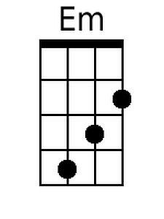
 |  |  |  |  |  |  | 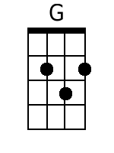
 |  |  |  |  |  |  | 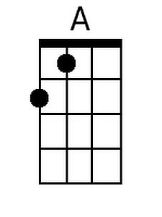
 |  |  |  |  |  |  | 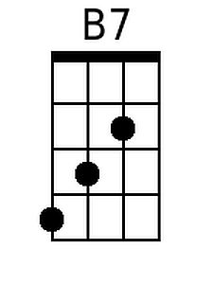
Strum:  1 2& 3&  D DU DU |  | Bari | 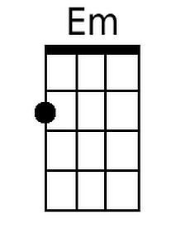 | 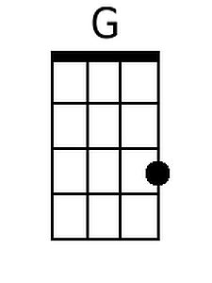 | 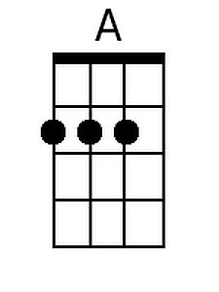 |  | 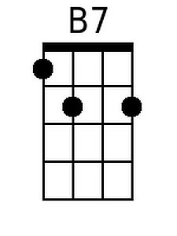

Note: Repetition of the Intro after every verse is optional.

