**Hula Heaven (Ralph Rainger / Leo Robin 1937 / Teresa Bright)**

**Intro: C F C A7 / D7 G7 C G7**



C

F



**C F C A7**

We could be together

**D7**

In a little hula heaven

**G7 C G7**

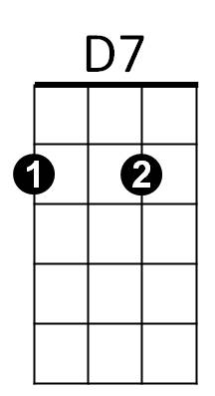Having dreams of love

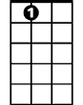

A7

**C F C A7**

So gay and free together

**D7**

In a little hula heaven

**G7 C C7**

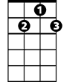

G7

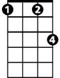

Fm

Under a koa tree

**Chorus:**

**F Fm**

Days would be lazy

**C A7**

And sweetly crazy

**D7 G7**

Skies would grow hazy above

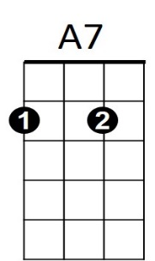 **C F C A7**

**BARITONE**



F



D7

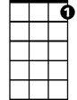

G7

C



And we'd be all alone t ogether

**D7**

In a little hula heaven

**G7 C C7**

Over a silvery sea

**(Chorus)**

**(Repeat through Chorus)**

**C F C A7**

And we'd be all alone together

**D7**

In a little hula heaven

**G7 C A7**

Over a silvery sea

**D7**

In a little hula heaven

**D#7**

In a little hula heaven

**D7**

In a little hula heaven

**G7 C Csus4 C**

Having dreams of love

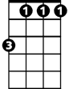

Fm