**Fun, Fun, Fun (Michael Love / Brian Wilson) Key C**

**Intro: C / F C G F G**

**C**

Well she got her daddy's car and she's cruisin'

**F**

through the hamburger stand now

**C**

Seems she forgot all about the library

**G G7**

Like she told her old man now

**C**

And with the radio blasting

**C7 F**

Goes cruising just as fast as she can now

**Chorus**

**C G**

And she'll have fun fun fun

**F G C**

'Til her daddy takes the T-Bird away

**F C G**

(Fun fun fun 'til her daddy takes the T-Bird away)

**C**

Well the girls can't stand her

**F**

'Cause she walks looks and drives like an a ce now

(You walk like an ace now you walk like an ace)

**C**

She makes the Indy 500 look like

**G**

a Roman chariot race now

**D7 G7**

(You look like an ace now you look like an ace)

**C**

A lotta guys try to catch her

**F**

But she leads them on a wild goose chase now

(You drive like an ace now you drive like an ace)



C

**(Chorus)**

**Intrumental/Solo G / C / G / D7 G7**

**BARITONE**



G



F

C



**C**

Well you knew all along

**F**

That your dad was gettin' wise to you now

(You shouldn't have lied now you shouldn't have lied)

**C**

And since he took your set of keys

**G**

You've been thinking that your fun is all through now

**D7 G7**

(You shouldn't have lied now you shouldn't have lied)

**C**

But you can come along with me

**F**

'Cause we gotta a lot of things to do now

(You shouldn't have lied now you shouldn't have lied)

**C G**

And we'll have fun fun fun

**F G C**

Now that daddy took the T-Bird away

**F C G C**

(Fun fun fun now that daddy took the T-Bird away)

**G**

And we'll have fun fun fun

**F G C**

Now that daddy took the T-Bird away

**F C G**

(Fun fun fun now that daddy took the T-Bird away)

**Outro (repeat and fade)**

**G C**

(fun fun now that daddy took the T-Bird away)

**F C G**

(fun fun now that daddy took the T-Bird away)

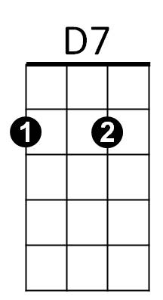

F



G

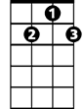

G7

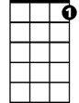

G7



D7

**Fun, Fun, Fun (Michael Love / Brian Wilson) Key G**

**Intro: G / C G D C D**

**G**

Well she got her daddy's car and she's cruisin'

**C**

through the hamburger stand now

**G**

Seems she forgot all about the library

**D D7**

Like she told her old man now

**G**

And with the radio blasting

**G7 C**

Goes cruising just as fast as she can now

**Chorus**

**G D**

And she'll have fun fun fun

**C D G**

'Til her daddy takes the T-Bird away

**C G D**

(Fun fun fun 'til her daddy takes the T-Bird away)

**G**

Well the girls can't stand her

**C**

'Cause she walks looks and drives like an ace now

(You walk like an ace now you walk like an ace)

**G**

She makes the Indy 500 look like

**D**

a Roman chariot race now

**A7 D7**

(You look like an ace now you look like an ace)

**G**

A lotta guys try to catch her

**C**

But she leads them on a wild goose chase now

(You drive like an ace now you drive like an ace)



G

**(Chorus)**

**Intrumental/Solo D / G / D / A7 D7**



D

C



G

**G**

Well you knew all along

**C**

That your dad was gettin' wise to you now

(You shouldn't have lied now you shouldn't have lied)

**G**

And since he took your set of keys

**D**

You've been thinking that your fun is all through now

**A7 D7**

(You shouldn't have lied now you shouldn't have lied)

**G**

But you can come along with me

**C**

'Cause we gotta a lot of things to do now

(You shouldn't have lied now you shouldn't have lied)

**G D**

And we'll have fun fun fun

**C D G**

Now that daddy took the T-Bird away

**C G D G**

(Fun fun fun now that daddy took the T-Bird away)

**D**

And we'll have fun fun fun

**C D G**

Now that daddy took the T-Bird away

**C G D**

(Fun fun fun now that daddy took the T-Bird away)

**Outro (repeat and fade)**

**D G**

(fun fun now that daddy took the T-Bird away)

**C G D**

(fun fun now that daddy took the T-Bird away)





C

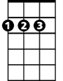

D

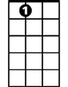

A7

**BARITONE**

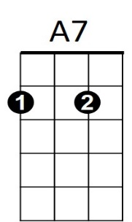



D7