I Am a Pilgrim (Doc Watson) Key C

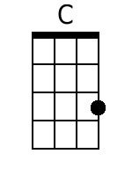
Intro: Chords for verse

Chorus:
C G7 C
I am a pilgrim and a stranger
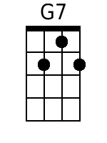
F C
Traveling through this wearisome land
F
I've got a home in that yonder city good Lord
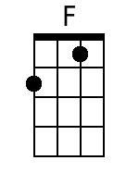
C Tacet G7 Tacet C
And it's not ~ Oh Lordy it’s not ~ not made by hand.

Outro: C C F F _ C
G7 C
1. I've got a mother a sister and brother
F C
Who have gone to that other shore
F
I am determined to go and see them good Lord
C Tacet G7 Tacet C
And live ~ with them ~ forever-more.
Baritone
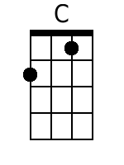
G7 C
2. I'm going down to that river of Jordan
F C
Just to bathe my wearisome soul
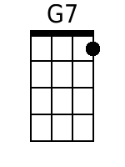
F
If I could just touch the hem of His garment good Lord
C Tacet G7 Tacet C
Then I know ~ Oh Lordy, I know ~ He'll make me whole.

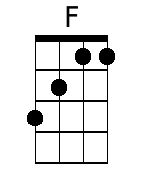
G7 C
3. Now when you’ve laid me down in my coffin
F C
With these old tired hands resting on my breast
F
I don’t want you to do that ol’ crying over me
C Tacet G7 Tacet C
Because you know ~ ~ I’ve gone to rest. (Chorus)

