**I Am Hawaiʻi (Mack David / Elmer Bernstein)**

**C F G7 Am**

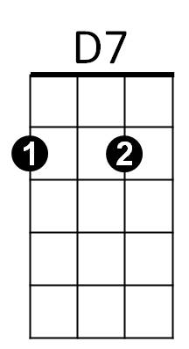I am Hawaiʻi, I am forever



C

F

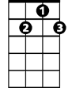

G7



G

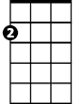

Am

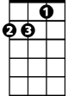

Dm

E7

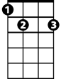

**F G Am D7 E7**

I will always be kind to you

**Dm F Em7**

May gentle rain wash your cares far out to sea

**Em Am D7 E7 G7**

Come you dreamers and dream with me

**C F G7 Am**

I am Hawaiʻi, I am the flowers

**F G Am D** **7 G7**

Whispering waters, enchanted hours

**F G7 C Am**

Come you lovers, come to forever

**C F G7 C**

I am Hawaiʻi, I'll bring you love

Em

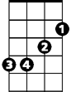

Em7

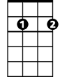

**(Play G7 to repeat song, slow last line end C)**

**BARITONE**

C



F



G

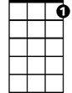

G7



Am



D7

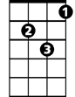

Dm

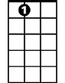

E7



Em

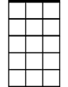

Em7