**I Am Woman (Ray Burton / Helen Reddy)**

**G C**

I am woman, hear me roar,

**Bm Em**

In numbers too big to ignore;

**C G C D**

And I know too much to go back and pretend

**G C**

'Cause I've heard it all before,

**Bm Em**

And I've been down there on the floor;

**C G D C7**

No one's ever gonna keep me down again

**Chorus:**

**F**

Oh, yes I am wise;

**Bb F**

But it's wisdom born of pain

**F**

Yes, I've paid the price;

**Bb Am**

But look how much I gained

**Dm Bb Am**

If I have to, I can do anything

**Gm**

I am strong, (strong)

**F**

I am invincible, (invincible)

**Bb G**

I am wo - man

**G C**

You can bend but never break me,

**Bm Em**

'Cause it only serves to make me;

**C G C D**



G

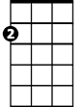

Em

C



Bm

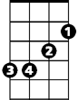

**BARITONE**

More determined to achieve my final goal

**G C**

And I come back even stronger,

**Bm Em**

Not a novice any longer;

**C**

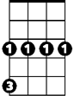

Gm

'Cause you've deepened

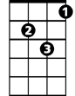

Dm



F

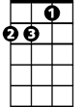

Am

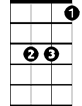

Bb

**G D C7**

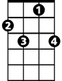

C7

The conviction in my soul

**(Chorus)**

**G C**

I am woman watch me grow,

**Bm Em**

See me standing toe to toe;

**C G C D**

As I spread my lovin' arms across the land

**G C**

But I'm still an embryo,

**Bm Em**

With a long long way to go;

**C G D C7**

Until I make my brother understand

**(Chorus)**

**Gm**

I am strong, (strong)

**F**

I am invincible, (invincible)

**Bb G**

I am wo - man



D

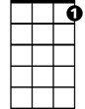

C7



C



G



Bb



Am

F



Gm



Dm

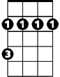

Bm

Em

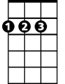

D