**I Am a Pilgrim (Doc Watson) Key G**

**Intro: Chords for verse**

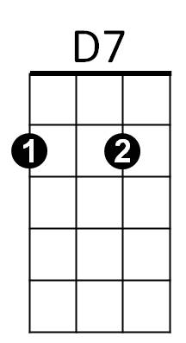**Chorus:**



G



C

**G D7 G**

I am a pilgrim and a stranger

**C G**

Traveling through this wearisome land

**C**

I've got a home in that yonder city good Lord

**G / TACET D7 / G**

/ = Single strum

And it's not ~ Oh Lordy it’s not, not made by hand

**D7 G**

I've got a mother a sister and brother

**C G**

Who have gone to that other shore

**C**

I am determined to go and see them good Lord

**G/ TACET D7/ G**

And live Good Lordy with them - forevermore

**D7 G**

I'm going down to that river of Jordan

**BARITONE**

**C G**

Just to bathe my wearisome soul

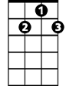

D7



G

**C**

If I could just touch the hem of His garment good Lord

**G/ TACET D7/ G**

Then I know - Oh Lordy, I know, He'll make me whole

**D7 G**

C



Now when you’ve laid me down in my coffin

**C G**

With these old tired hands resting on my breast

**C**

I don’t want you to do that ol’ crying over me

**G/ TACET D7/ G**

Because you know - Oh Lordy, you know, I’ve gone to rest

**(Chorus)**