I Am a Pilgrim (Doc Watson) | 312
Tempo = 155 | Presto
Intro: Last two lines of Chorus
/ = Single strum
Chorus:
(G) D7 |  | G
I am a pilgrim |  | and a stranger
C |  | G
Traveling through |  | this wearisome land
G |  | C
I've got a home in |  | that yonder city good Lord
G / TACET D7 / TACET G
And it's not - | Oh Lordy, it’s not - |  | not made by hand.

D7 | G
1. I've got a mother | a sister and brother,
C | G
Who have gone to | that other shore.
G | C
I am de-ter-mined | to go and see them, good Lord.
G / TACET D7 / TACET G
And live - Good Lordy, with them - forever-more.

D7 | G
2. I'm going down to | that river of Jordan,
C | G
Just to bathe | my wearisome soul.
G | C
If I could just touch | the hem of His garment, good Lord.
G/ TACET D7/ TACET G
Then I know - Oh Lordy, I know - He'll make me whole.

Baritone
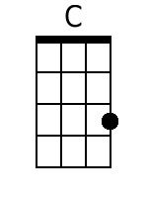 | 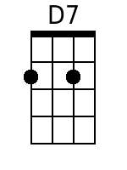 |  | 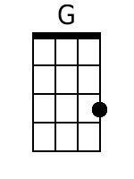 | 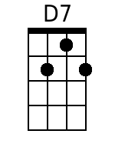 | 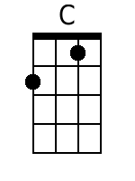

D7 |  | G
3. Now when you’ve laid me |  | down in my coffin,
C |  | G
With these old tired hands |  | resting on my breast.
G |  | C
I don’t want you to |  | do that ol’ crying over me.
G/TACET D7/TACET G
Because you know - | Oh Lordy, you know - |  | I’ve gone to rest.

Chorus:
(G) D7 |  | G
I am a pilgrim |  | and a stranger
C |  | G
Traveling through |  | this wearisome land
G |  | C
I've got a home in |  | that yonder city good Lord
G / TACET D7 / TACET G
And it's not - | Oh Lordy, it’s not - |  | not made by hand.

Outro: C C F F C C C

