I Believe In Music (Mac Davis) Arr. Pete McCarty (C)

Intro (Four Measures): C Dm F G  C Dm  I could just sit around, making music all day long.  G F C  As long as I'm makin music I know I can't do nobody wrong.  Dm  And who knows, maybe someday, I'll come up with a song  G  makes people want to stop their fussing and fighting  F C  Just Long enough to sing along.  C Dm F G C  I believe in music I - I believe in love  C Dm  Music is love and love is music if you know what I mean  G F C  People who believe in music are the happiest people I've ever seen  Dm  So clap your hands and stomp your feet and shake your tambourines  G F C  Lift your voices to the sky, God loves you when you sing.  Everybody sing,  C Dm F G C  I believe in music I - I believe in love  C Dm F G C  I believe in music I - I believe in love  C Dm  Music is the universal language, and love is the key  G F C  To brotherhood, peace and understanding, and living in har-mo-ny  Dm  So take your brother by the hand and sing along with me  G F C  Find out what it really means to be young and rich and free.  Outro (Repeat Twice)  C Dm F G C  I believe in music I - I believe in love  C Dm F G C  I believe in music I - I believe in love  C Dm F G C C  I believe in music I - I believe in love. Hold Last Chord |  |  |  |  |  |  | 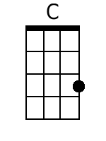
 |  |  |  |  |  |  | 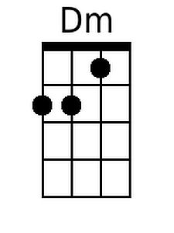
 |  |  |  |  |  |  | 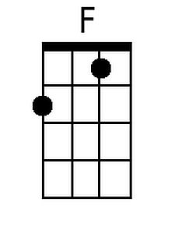
 |  |  |  |  |  |  | 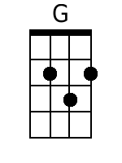
Baritone
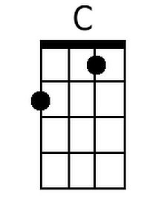 | 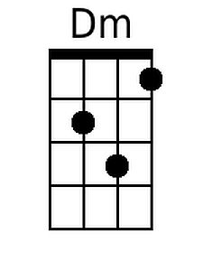 | 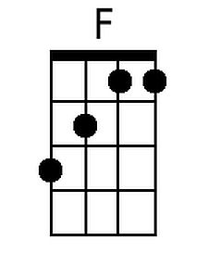 | 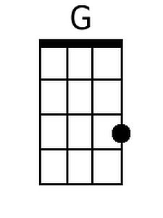

I Believe In Music (Mac Davis) Arr. Pete McCarty (G)

Intro (Four Measures): G Am C D

G Am
I could just sit around, making music all day long.
D C G
As long as I'm makin music I know I can't do nobody wrong.
Am
And who knows, maybe someday, I'll come up with a song
D
makes people want to stop their fussing and fighting
C G
Just Long enough to sing along.
G Am C D G
I believe in music I - I believe in love

G Am
Music is love and love is music if you know what I mean
D C G
People who believe in music are the happiest people I've ever seen
Am
So clap your hands and stomp your feet and shake your tambourines
D C G
Lift your voices to the sky, God loves you when you sing.

Everybody sing,
G Am C D G
I believe in music I - I believe in love
G Am C D G
I believe in music I - I believe in love

G Am
Music is the universal language, and love is the key
D C G
To brotherhood, peace and understanding, and living in har-mo-ny
Am
So take your brother by the hand and sing along with me
D C G
Find out what it really means to be young and rich and free.

Outro (Repeat Twice)
G Am C D G
I believe in music I - I believe in love
G Am C D G
I believe in music I - I believe in love
G Am C D G G
I believe in music I - I believe in love Hold Last Chord
 |  |  |  |  |  |  | 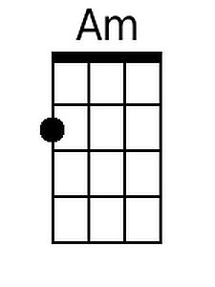
 |  |  |  |  |  |  | 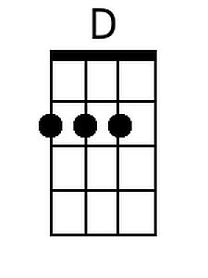
Baritone
 | 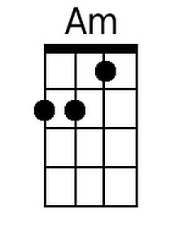 |  | 