**I Can See Clearly Now (Johnny Nash) Key C**

**C F C**



Bb

F



G



C

I can see clearly now the rain is gone

**C F G**

I can see all obstacles in my way

**C F C**

Gone all the dark clouds that had me blind

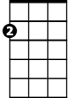

Am

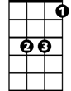

Eb

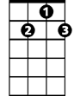

G7

**Bb F C**

It's gonna be a b right, (bright) bright, (bright) sun shiny day

**Bb F C**

It's gonna be a bright, (bright) bright, (bright) sun shiny day

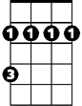

Bm

**C F C**

I think I can make it now the pain is gone,

**C F G**

All of the bad feelings have disappeared.

**C F C**

Here is the rainbow I have been praying for.

**B** **b F C**

It's gonna be a bright, (bright) bright, (bright) sun shiny day

**Eb Bb**

Look all around, there's nothing but blue skies

**Eb G7 Bm F Bm F C Am G7**

Look straight ahead, there's nothing but blue skiiiiiiiiiiiiiiiiiiiiiiiies

**BARITONE**

**C F C**



Bb



G



F

C



I can see clearly now the rain is gone

**C F G**

I can see all obstacles in my way

**C F C**

Gone all the dark clouds that had me blind

**Bb F C**

It's gonna be a bright, (bright) bright, (bright) sun shiny day **(3x)**

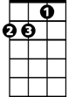

Am

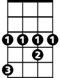

Eb

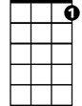

G7

Bm

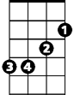

**I Can See Clearly Now (Johnny Nash) Key D**

**D G D**

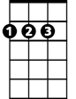

D

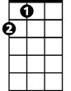

A



G



C

I can see clearly now the rain is gone

**D G A**

I can see all obstacles in my way

**D G D**

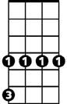

C#m

Gone all the dark clouds that had me blind

F



**C G D**

It's gonna be a bright, (bright) bright, (bright) sun shiny day

**C G D**

It's gonna be a bright, (bright) bright, (bright) sun shiny day

**D G D**

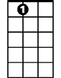

A7



Bm

I think I can make it now the pain is gone,

**D G A**

All of the bad feelings have disappeared.

**D G D**

Here is the rainbow I have been praying for.

**C G D**

It's gonna be a bright, (bright) bright, (bright) sun shiny day

**F C**

Look all around, there's nothing but blue skies

**F** **A7 C#m G C#m G C Bm A7**

Look straight ahead, there's nothing but blue skiiiiiiiiiiiiiiiiiiiiiiiies

**BARITONE**

**D G D**



G



D



A

C



I can see clearly now the rain is gone

**D G A**

I can see all obstacles in my way

**D G D**

Gone all the dark clouds that had me blind

**C G D**

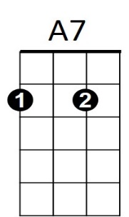It's gonna be a bright, (bright) bright, (bright) sun shiny day **(3x)**

Bm

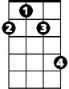

C#m



F

**I Can See Clearly Now (Johnny Nash) Key G**

**G C G**



G



C

F



D

I can see clearly now the rain is gone

**G C D**

I can see all obstacles in my way

**G C G**

Gone all the dark clouds that had me blind



F#m



Bb

**F C G**

It's gonna be a bright, (bright) bright, (bright) sun shiny day

**F C G**

It's gonna be a bright, (bright) bright, (bright) sun shiny day

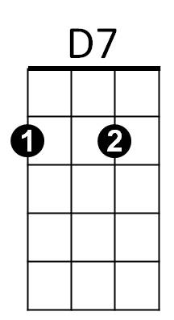



Am

**G C G**

I think I can make it now the pain is gone,

**G C D**

All of the bad feelings have disappeared.

**G C G**

Here is the rainbow I have been praying for.

**F C G**

It's gonna be a bright, (bright) bright, (bright) sun shiny day

**Bb F**

Look all around, there's nothing but blue skies

**Bb D7 F#m C F#m C F Am D7**

Look straight ahead, there's nothing but blue skiiiiiiiiiiiiiiiiiiiiiiiies

**BARITONE**

**G C G**



G

C



D



F

I can see clearly now the rain is gone

**G C D**

I can see all obstacles in my way

**G C G**

Gone all the dark clouds that had me blind

**F C G**

It's gonna be a bright, (bright) bright, (bright) sun shiny day **(3x)**



D7



Am



F#m



Bb