**I Feel Fine (Lennon / McCartney)**

**Intro: C Bb G**



C



Bb



G

**G**

Baby's good to me, you know,

**D**

She’s happy as can be, you know, she said so.

**C7 G**

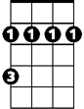

Bm

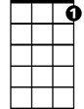

C7

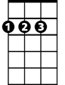

D

I'm in love with her and I feel fine.

**G**

Baby says she's mine, you know,

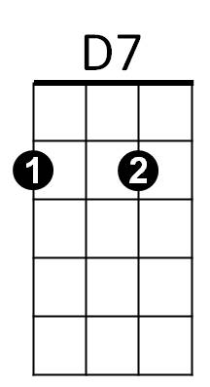 **D**

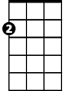

Am

She tells me all the time, you know, she said so.

**C7 G**

I'm in love with her and I feel fine.

**G Bm C D7**

I'm so glad that she's my little girl.

**G Bm Am D7**

She's so glad, she's telling all the world.

**G**

That her ba by buys her things, you know,

**D**

**BARITONE**

He buys her diamond rings, you know, she said so.



G

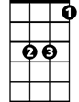

Bb

C



D

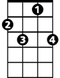

C7

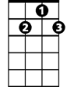

D7

**D7 C7 G**

She's in love with me and I feel fine.

**Instrumental verse**

**Repeat from 2d verse**

Bm

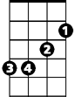

**D7 C7 G**

She's in love with me and I feel fine.

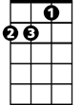

Am