I Got You Babe (Sonny Bono, 1965)
I Got You Babe by Sonny & Cher (1965) – Key of D

Intro: | D G | D A |  D G  They say we're young and we don't know  D G - C A A7  Won't find out un-til we grow  D G  Well I don't know if all that's true  D G C A A7  ‘Cause you got me and baby I got you  D G D G D G  Babe. I got you babe, I got you babe.  D G  They say our love won't pay the rent  D G C A A7  Be-fore it's earned our money's all been spent  D G  I guess that's so we don't have a pot  D G C A A7  But at least I'm sure of all the things we got  D G D G D G  Babe. I got you babe, I got you babe.  [Stop]  Em A  I got flowers in the spring  Em A  I got you to wear my ring  D G  And when I'm sad you're a clown  Em A A7  And if I get scared you're always a-round |  |  |  |  | D G  So let them say your hair's too long,  D G C A A7  But I don't care, with you I can't go wrong.  D G  Then put your little hand in mine,  D G C A A7  There ain't no hill or mountain we can't climb.  D G D G D G  Babe. I got you babe, I got you babe.  | D G | D A |  D G D A  I got you to hold my hand, I got you to understand.  D G D A  I got you to walk with me, I got you to talk with me.  D G  I got you to kiss goodnight,  D A  I got you to hold me tight.  D G D A  I got you, I won't let go, I got you to love me so.  | D G | D A | [Stop]  G D  I got . . . you . . . babe.  G D A7  I got you babe. _ (3x) [Stop]  G D  I got . . . you . . . babe.
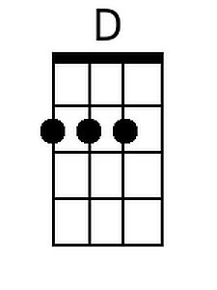 | 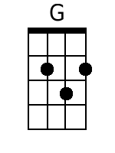 | 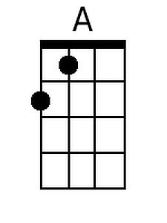 | 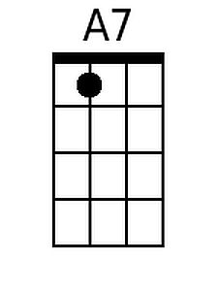 | 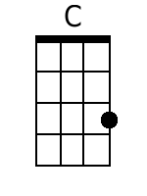 |  | 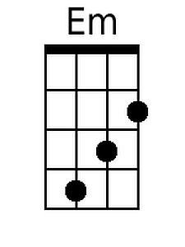 |  |  | Women  Men  Both
Bari
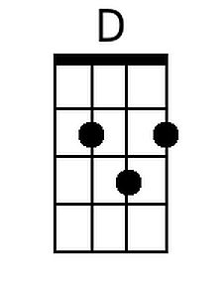 | 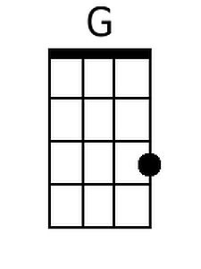 | 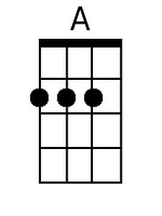 | 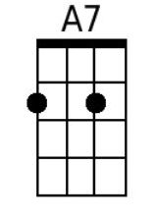 | 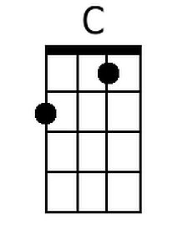 |  | 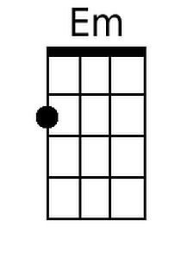

I Got You Babe (Sonny Bono, 1965)
I Got You Babe by Sonny & Cher (1965) – Key of G

Intro: | G C | G D |  G C  They say we're young and we don't know  G C F D  Won't find out un-til we grow  G C  Well I don't know if all that's true  G C F D D7  Cause you got me and baby I got you  G C G C G C  Babe. I got you babe, I got you babe.  G C  They say our love won't pay the rent  G C F D  Be-fore it's earned our money's all been spent  G C  I guess that's so we don't have a pot  G C F D  But at least I'm sure of all the things we got  G C G C G C  Babe. I got you babe, I got you babe.  [Stop]  Am D  I got flowers in the spring  Am D  I got you to wear my ring  G C  And when I'm sad you're a clown  Am D  And if I get scared you're always a-round |  |  |  |  | G C  So let them say your hair's too long,  G C F D  But I don't care, with you I can't go wrong.  G C  Then put your little hand in mine,  G C F D  There ain't no hill or mountain we can't climb.  G C G C G C  Babe. I got you babe, I got you babe.  | G C | G D |  G C G D  I got you to hold my hand, I got you to understand.  G C G D  I got you to walk with me, I got you to talk with me.  G C  I got you to kiss goodnight,  G D  I got you to hold me tight.  G C G D  I got you, I won't let go, I got you to love me so.  | G C | G D | [Stop]  C G  I got . . . you babe.  C G D7  I got you babe. _ (3x) [Stop]  C G  I got . . . you babe.
 |  |  | 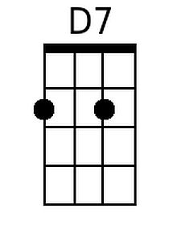 | 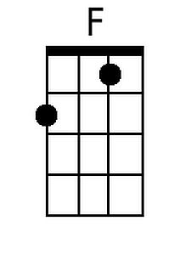 |  | 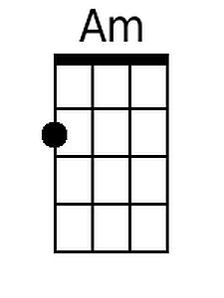 |  |  | Women  Men  Both
Bari
 |  |  | 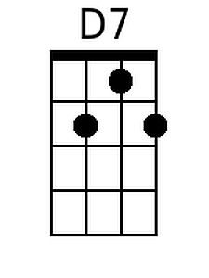 | 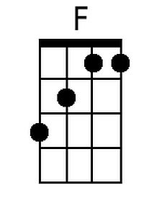 |  | 