**I Got the Sun in the Morning (Irving Berlin)**

**A7 D A7 D**

Got no diamond, got no pearl

**A7 D E7 D**

Still I think I'm a lucky girl

**D G A7 D**

I got the sun in the morning and the moon at night

**D G A7 D**

I got the sun in the morning and the moon at night

**A7 D A7 D**

Got no mansion, got no yacht

**A7 D E7 D**

Still I'm happy with what I've got

**D G A7 D**

I got the sun in the morning and the moon at night

**D G A7 D**

I got the sun in the morning and the moon at night

**F#7 B7**

Sunshine gives me a lucky day

**E7 A7**

Moonlight gives me the Milky Way

**A7 D A7 D**

Got no checkbooks, got no banks

**A7 D E7 D**

Still I'd like to express my thanks

**D G A7 D**

I got the sun in the morning and the moon at night

**D G A7 D**

I got the sun in the morning and the moon at night

**D G**

And with the sun in the morning

**Em7 A7 Em7 A7 D**

And the moon in the evening - I'm all right

**A7 D A7 D**

Got no butler, got no maid

**A7 D E7 D**

Still I think I've been over - paid

**D G A7 D**

I got the sun in the morning and the moon at night

**D G A7 D**

I got the sun in the morning and the moon at night

**A7 D A7 D**

Got no silver, got no gold

**A7 D E7 D**

What I got can't be bought or sold

**D G A7 D**

I got the sun in the morning and the moon at night

**D G A7 D**

I got the sun in the morning and the moon at night

**F#7 B7**

Sunshine gives me a lucky day

**E7 A7**

Moonlight gives me the Milky Way

**A7 D A7 D**

Got no checkbooks, got no banks

**A7 D E7 D**

Still I'd like to express my thanks

**D G A7 D**

I got the sun in the morning and the moon at night

**D G**

And with the sun in the morning

**Em7 A7 Em7 A7 D**

And the moon in the evening - I'm all right

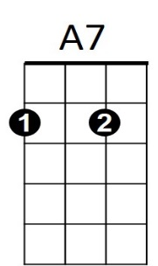

**BARITONE**

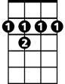

F#7

B7

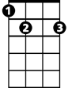

D

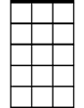

Em7

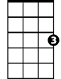

G

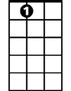

E7

Em7

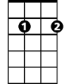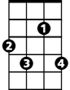

F#7



G



A7

E7

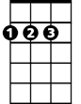

D