**I Guess That's Why They Call It the Blues**

**(Elton John, Davey Johnstone, Bernie Taupin)**

**Intro: C G F 2x**

**G**

Don't wish it away

**Bm F C F C F C F C**

Don't look at it's like it's forever

**C G Bm**

Between you and me I could honestly say

**F C F C F C F C**



C

That things can only get better

**C G**

And while I'm away,

**B7 Em**

Dust out the demons inside

**C**



G

F

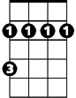

Bm

And it won't be long

**Em G**

Before you and me run

**Am**

To the place in our hearts

**F G C G Am G**

Where we hide

**Chorus:**

**C**

And I guess that's why

**G F**

Em

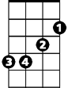

They call it the blues

**C**

Time on my hands,

**G F**

Could be time spent with you

**C G**

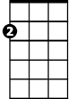

Am

Laughing like children,

**Am**

Living like lovers,

**C F**

Rolling like thunder,

**D**

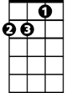

Am

under the covers

**F**

And I guess that's why

**C G Em F**

They call it the blues

**G**

Just stare into space

**Em F C F C F C F C**

Picture my face in your hands

**C G Bm**

Live for each second without hesitation

**F C F C F C F C**

And never forget I'm your man

**C G**

Wait on me girl

**B7 Em G**

Cry in the night if it helps

**G7 C G**

But more than ever I simply love you

**Am F G C G Am G**

More than I love life itself

**(Chorus)**

**C G**

Wait on me girl

**B7 Em G**

Cry in the night if it helps

**G7 C G**

But more than ever I simply love you

**Am F G C G Am G**

More than I love life itself

**(Chorus)**

**(2x)**

**F G C**

And I guess that's why they call it the blues



Em

B7

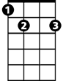

Bm



F



G

C



**BARITONE**