I Guess That's Why They Call It the Blues (G)
(Elton John, Davey Johnstone, Bernie Taupin)

Intro: G D C (2x)  D  Don't wish it away  F#m C G C G C G C G  Don't look at it's like it's forever  G D F#m  Between you and me I could honestly say  C G C G C G C G  That things can only get better  G D F#7 Bm  And while I'm away, dust out the demons in-side  G Bm D  And it won't be long before you and me run  Em C D G D Em D  To the place in our hearts where we hide  Chorus:  G D C  And I guess that's why they call it the blues  G D C  Time on my hands, could be time spent with you  G D Em  Laughing like children, living like lovers,  G C A  Rolling like thunder, under the covers  C G D Bm C  And I guess that's why they call it the blues |  |  |  |  |  | 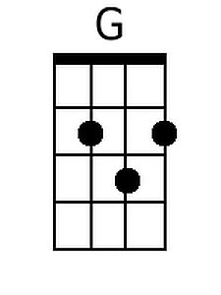  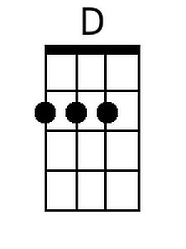  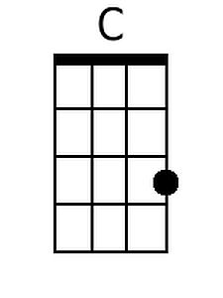  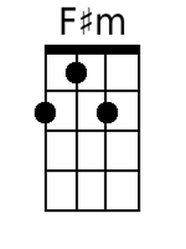  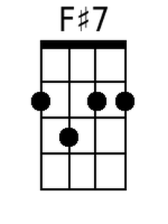  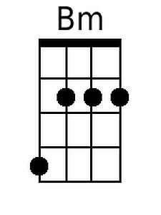  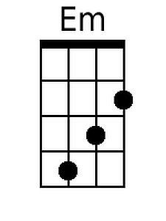
Bari
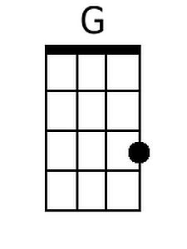 | 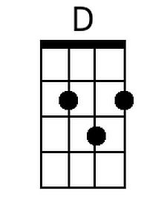 | 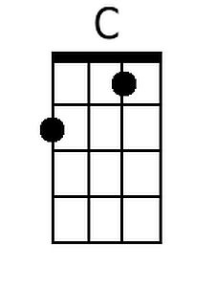 | 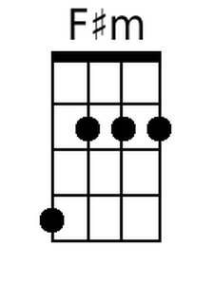
 | 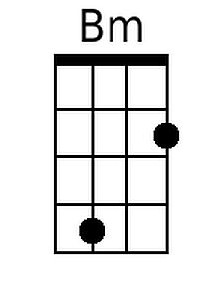 | 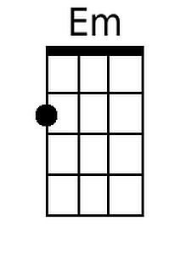

I Guess That’s Why They Call It The Blues - 2

D
Just stare into space
Bm C G C G C G C G
Picture my face in your hands
G D F#m
Live for each second without hesitation
C G C G C G C G
And never forget I'm your man
G D F#7 Bm D
Wait on me girl, cry in the night if it helps
D7 G D
But more than ever I simply love you
Em C D G D Em D
More than I love life itself
(Chorus)

G D F#7 Bm D
Wait on me girl, cry in the night if it helps
D7 G D
But more than ever I simply love you
Em C D G D Em D
More than I love life itself
(Chorus) (2x)

C D G
And I guess that's why they call it the blues.

