I Guess That's Why They Call It the Blues (G)
(Elton John, Davey Johnstone, Bernie Taupin)

Intro: G D C (2x)  D  Don't wish it away  F#m C G C G C G C G  Don't look at it's like it's forever  G D F#m  Between you and me I could honestly say  C G C G C G C G  That things can only get better  G D  And while I'm away,  F#7 Bm  Dust out the demons inside  G Bm D  And it won't be long before you and me run  Em  To the place in our hearts  C D G D Em D  Where we hide  Chorus:  G D C  And I guess that's why they call it the blues  G  Time on my hands,  D C  Could be time spent with you  G D Em  Laughing like children, living like lovers,  G C A  Rolling like thunder, under the covers  C G D - Bm C  And I guess that's why they call it the blues |  |  | D  Just stare into space  Bm C G C G C G C G  Picture my face in your hands  G D F#m  Live for each second without hesitation  C G C G C G C G  And never forget I'm your man  G D  Wait on me girl  F#7 Bm D  Cry in the night if it helps  D7 G D  But more than ever I simply love you  Em C D G D Em D  More than I love life itself  (Chorus)  G D  Wait on me girl  F#7 Bm D  Cry in the night if it helps  D7 G D  But more than ever I simply love you  Em C D G D Em D  More than I love life itself  (Chorus) (2x)  C D G  And I guess that's why they call it the blues |  |  | 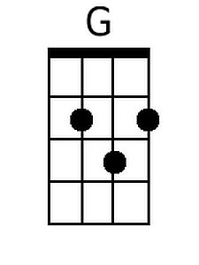  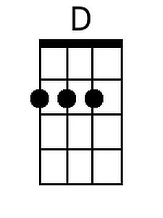  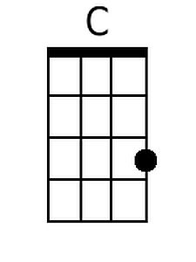  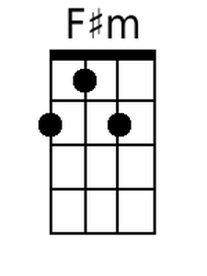  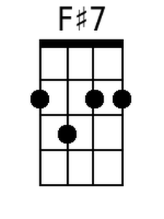  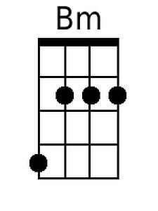  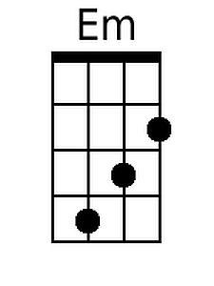
Bari
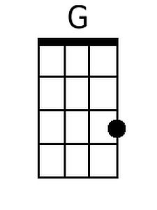 | 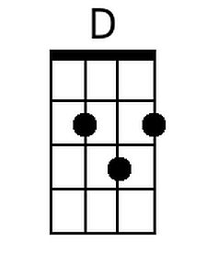 | 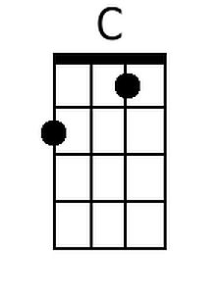 | 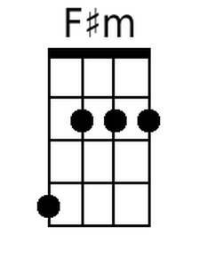
 | 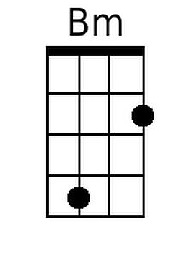 | 