I Just Called to Say I Love You (Stevie Wonder) Key G
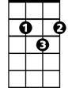
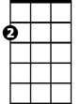
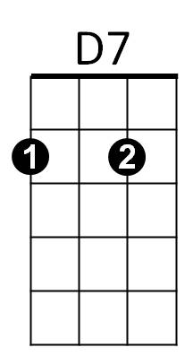
Intro: Am D7 G
G
Am
Gmaj7 G Gmaj7 G Gmaj7
No New Year's Day to cele- brate
G Am AmMaj7
No chocolate covered candy hearts to give away
Am AmMaj7 Am AmMaj7
No first of spring No song to sing
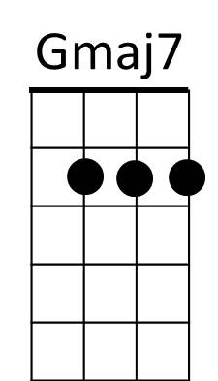
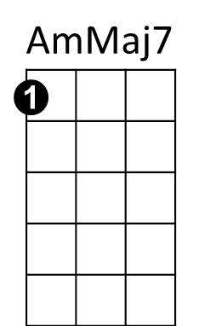
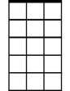
Am7 D Gmaj7 G
Am7
In fact here's just another ordi-nary day

Gmaj7 G Gmaj7 G
No April rain No flowers bloom
Gmaj7 G Am AmMaj7
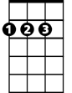
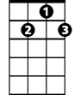
No wedding Satur-day within the month of June
Am AmMaj7 Am AmMaj7
D
G7
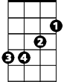
But what it is, is something true
Em
Am7 D Gmaj7 G
Made up of these three words that I must say to you

Chorus: Am D G
I just called to say I love you
Am D7 G G7
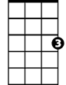
I just called to say how much I care
Am D G Em
G
BARITONE
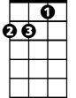
I just called to say I love you
Am
D7
Am D7 G
And I mean it from the bottom of my heart

Gmaj7 G Gmaj7 G
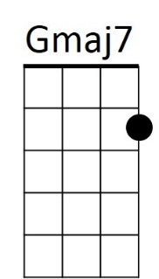
No summer's high No warm July
Gmaj7 G Am AmMaj7
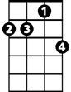
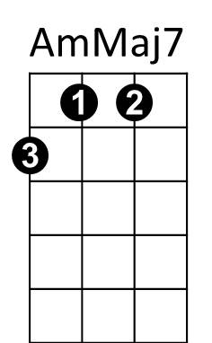
No harvest moon to light one tender August night
Am AmMaj7 Am AmMaj7
Am7
No autumn breeze No falling leaves
Am7 D Gmaj7 G
Not even time for birds to fly to southern skies

Gmaj7 G Gmaj7 G
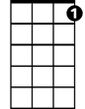
No Libra sun No Hallo - ween
Gmaj7 G Am AmMaj7
Em
D
G7
No giving thanks to all the Christmas joy you bring
Am AmMaj7 Am AmMaj7
But what it is, though old so new
Am7 D Gmaj7 G
To fill your heart like no three words could ever do

Repeat Chorus 2x
Am D7 G Gmaj7 Am D7 G
And I mean it from the bottom of my heart Baby of my heart

I Just Called to Say I Love You (Stevie Wonder) Key of C
C
Dm
G7
Intro: Dm G7 C
Cmaj7 C Cmaj7 C Cmaj7
No New Year's Day to cele- brate
C Dm Asus4
No chocolate covered candy hearts to give away
Dm Asus4 Dm Asus4
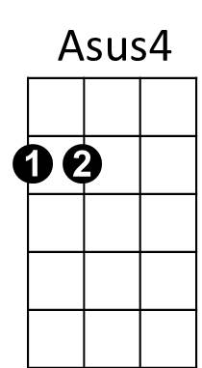
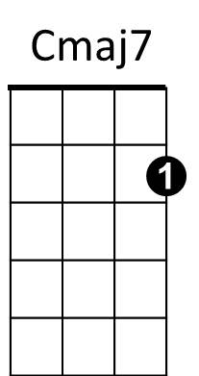
No first of spring No song to sing
G
Dm7 G Cmaj7 C
In fact here's just another ordinary day

Cmaj7 C Cmaj7 C Cmaj7
No April rain No flowers bloom
C Dm Asus4
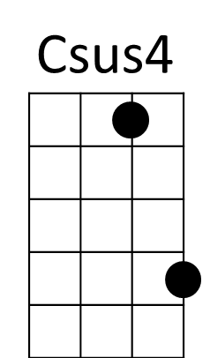
No wedding Saturday within the month of June
Dm Asus4 Dm Asus4
Am
Dm7
But what it is, is something true
Dm G C
Made up of these three words that I must say to you

Chorus: Dm G C
I just called to say I love you
Dm G7 C
I just called to say how much I care
Dm G C Am
BARITONE
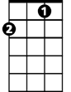
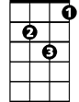
I just called to say I love you
G7
C
Dm
Dm G7 C
And I mean it from the bottom of my heart

Cmaj7 C Cmaj7 C Cmaj7
No summer's high No warm July
C Dm Asus4
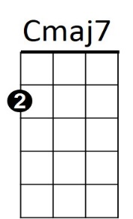
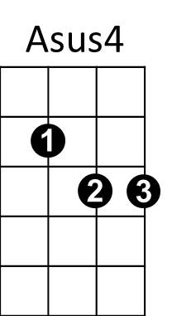
No harvest moon to light one tender August night
Dm Asus4 Dm Asus4
G
No autumn breeze No falling leaves
Dm7 G Cmaj7 C
Not even time for birds to fly to southern skies

Cmaj7 C Cmaj7 C Cmaj7
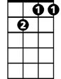
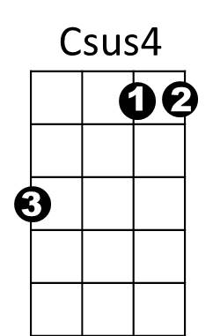
No Libra sun No Hallo - ween
Am
Dm7
C Dm Asus4
No giving thanks to all the Christmas joy you bring
Dm Asus4 Dm Asus4
But what it is, though old so new
Dm7 G C
To fill your heart like no three words could ever do

Repeat Chorus 2x

Dm G7 C Csus4 C Csus4 C G7 C
And I mean it from the bottom of my heart - of my heart - of my heart - Baby of my heart

