I Like Bananas Because They Have No Bones (A)
Lyrics: Lorraine Milne; Music: Chris Yacich
I Like Bananas Because They have No Bones by George Elrick (1936)

A E7 A  Standing by the fruit stall on the corner (on the corner)  A E7 A  Once I heard a customer com-plain (he complained)  B7 E B7 E  You never seem to show (uh-uh), the fruit we all love so (oh, no)  B7 E E7  That’s why business hasn’t been the same (been the same)  A B7  I don't like your peaches. They are full of stones.  E7 A  I like bananas because they have no bones.  A B7  Cherries are full of pits, I leave them alone.  E7 A  I like bananas because they have no bones.  Bridge  D Adim7 A  No matter where I go with Susie, May, or Anna.  B7 E E7  I want the world to know, I must have my ba-nana.  A B7  We can’t play the trumpet, don’t blow saxophones.  E7 A  We strum ukuleles for their mellow tones.  Kazoo verse  A B7  Do-do-do- do- do- do. Do-do-do do-do.  E7 A  Do-do-do- do- do. Do-do-do do-do. Repeat Bridge  A B7  Grapes with all those little seeds make my tummy groan.  E7 A  I like bananas because they have no bones.  A B7  Cabbages and onions hurt my singing tones.  E7 A  I like bananas because they have no bones.  E7 D E7 A / / / / E7 A  I like bananas because they—have—no—bones!! | 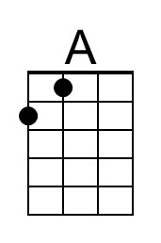 | 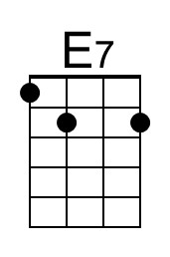
 | 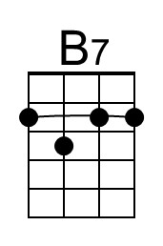 | 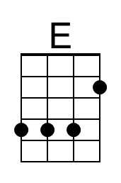
 | 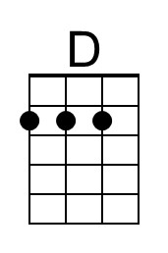 | 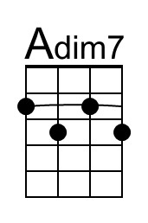
 | Bari
 | 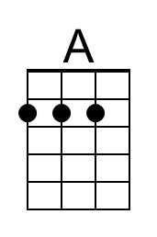 | 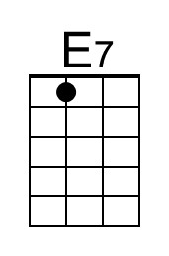
 | 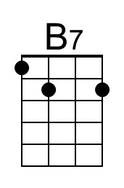 | 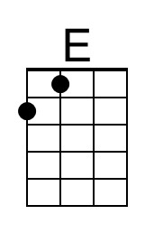
 | 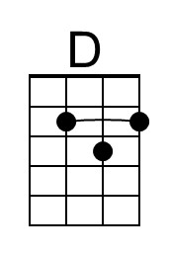 | 