I Like Bananas Because They Have No Bones
Lyrics Lorraine Milne, music Chris Yacich / Recorded by George Elrick 1936

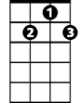
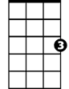
C G7 C
G7
C
Standing by the fruit stall on the corner (on the corner)
C G7 C
Once I heard a customer complain (he complained)
D7 G D7 G
You never seem to show (uh-uh) ..the fruit we all love so (oh, no)
D7 G G7
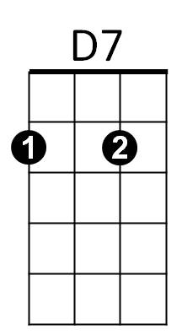
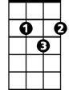
That’s why business hasn’t been the same (been the same)
G

C D7
I don't like your peaches They are full of stones
G7 C
I like bananas because they have no bones
C D7
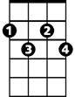
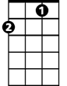
Cherries are full of pits, I leave them alone
Cdim
F
G7 C
I like bananas because they have no bones

Bridge: F Cdim C
No matter where I go with Susie, May, or Anna
D7 G G7
I want the world to know, I must have my banana

C D7
We can’t play the trumpet, don’t blow saxophones
G7 C
BARITONE
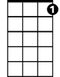
We strum ukuleles for their mellow tones
C
G7
Kazoo:
C D7
Do-do-do- do- do- do Do-do-do do-do
G7 C
Do-do-do- do- do Do-do-do do-do repeat Bridge

C D7
G
D7
Grapes with all those little seeds make my tummy groan
G7 C
I like bananas because they have no bones
C D7
Cabbages and onions hurt my singing tones
G7 C
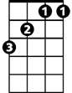
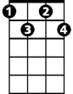
I like bananas because they have no bones
F
Cdim
G7 F G7 C / / / / G7 C
I like bananas because they—have—no—bones

https://www.youtube.com/watch?v=l-QkMaCS7CU&t=58s

