**I Love You More Today Than Yesterday (Patrick Upton)**

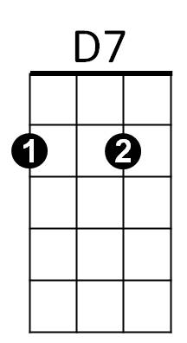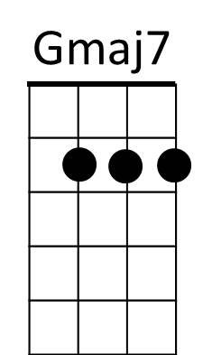 **Intro: G Am D7 x2**

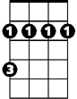

Bm

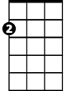

Am



G

**G Gmaj7 Am D7**

I don't remember what day it was

**G Gmaj7 Am D7**

I didn't notice what time it was

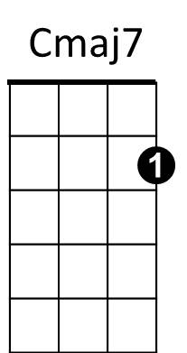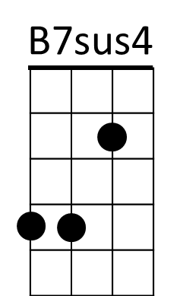**G Gmaj7 Am D7**

All I know is that I fell in love with you

Em7

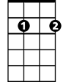

**Bm Cmaj7**

And if all my dreams come true

**Am D7**

I'll be spending time with you

**G Gmaj7 Am D7**

Every day's a new day in love with you

**G Gm** **aj7 Am D7**

With each day comes a new way of loving you

**G Gmaj7 Am D7**

Every time I kiss your lips my mind starts to wander

**Bm Cmaj7**

And if all my dreams come t rue

**Am D7**

**BARITONE**

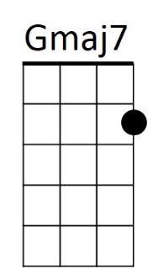I'll be spending time with you

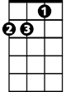

Am



G

**Chorus:**

**Cmaj7 B7sus4 B7**

Oh, I love you more today than yes – ter - day

**Cmaj7 Am B7sus4 B7**

But not as much as tomorrow

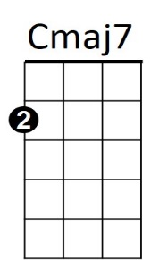**Cmaj7 B7sus4 B7**

Bm

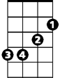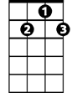

D7

I love you more today than yes – ter - day

**Em7 A C D7**

But, darling, not as much as tomorrow

**G Gmaj7 Am D7**

Tomorrow's date means springtime's just a day away

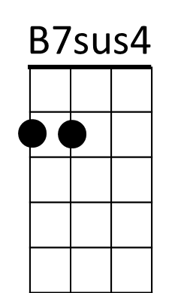**G Gmaj7 Am D7**

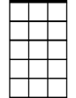

Em7

B7

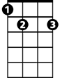

Cupid, we don't need ya now, be on your way

**G Gmaj7 Am D7**

I thank the Lord for love like ours that grows ever stronger

**Bm Am Cmaj7 D7**

And I always will be true, I know you feel the same way too

**(Chorus)**

**G Gmaj7 Am D7 3x TO FADE**

Every day's a new day, every time I love ya