I Melt With You
(Michael Conroy / Stephen Walker / Robert Grey / Gary McDowell / Richard Brown)

Intro: G C G C  G C  Moving forward using all my breath  G C  Making love to you was never second best  G C  I saw the world crashing all around your face  G C  Never really knowing it was always mesh and lace  Chorus:  G C  I'll stop the world and melt with you  G  You've seen the difference  C  And it's getting better all the time  G C  There's nothing you and I won't do  G C  I'll stop the world and melt with you  G C  Dream of better lives the kind which never hate  G C  Trapped in the state of imaginary grace  G C  I made a pilgrimage to save this humans race  G  What I'm comprehending  C  A race that's long gone by. Chorus. |  |  |  | Bm D Em G  Bm D Em G  The future's open wide  G C G C  G C  I'll stop the world and melt with you  G  You've seen some changes  C  And it's getting better all the time  G C  There's nothing you and I won't do  G C  I'll stop the world and melt with you  Bm D Em G  Bm D Em G  The future's open wide  (2X)  G  Hmmm hmmm hmmm  C  Hmmm hmmm hmmm hmmm  Chorus.  G C  I'll stop the world and melt with you  G C  I'll stop the world and melt with you |  |  |  | 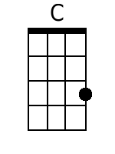
 |  |  |  |  |  |  |  | 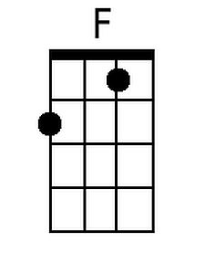
 |  |  |  |  |  |  |  | 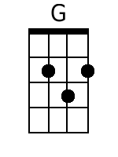
 |  |  |  |  |  |  |  | 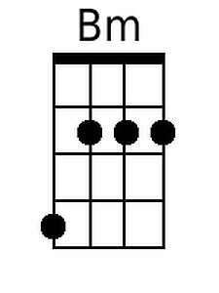
 |  |  |  |  |  |  |  | 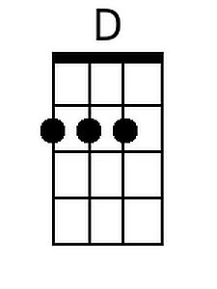
 |  |  |  |  |  |  |  | 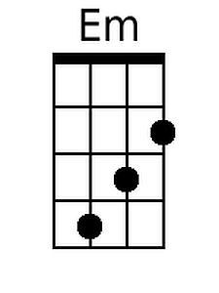
Bari
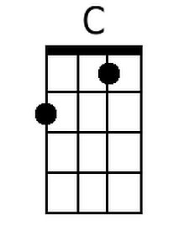 | 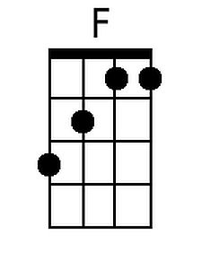 | 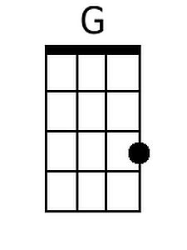 | 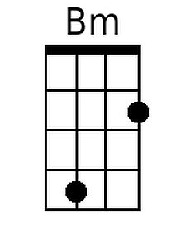 |  | 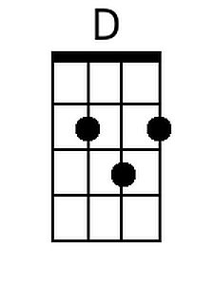 | 